Worksheet 2 Hunt The Lonelies

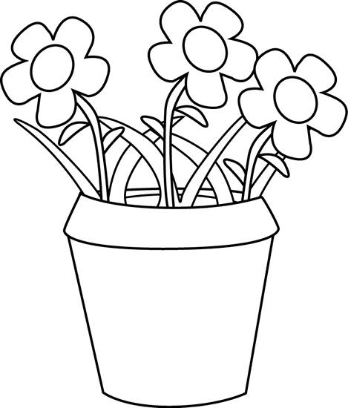
Arabella and ☹☹☹ Scott didn’t learn their ☹☹☹ lesson about being ☹☹☹ naughty.

At school ☹☹☹ they gave paint to ☹☹☹ the class plant instead of water. The ☹☹☹ plant turned purple with ☹☹☹ yellow spots. The whole ☹☹☹ class laughed ☹☹☹ for the rest of the day.

The next day they decided ☹☹☹ to paint the whiteboard in ☹☹☹ red and yellow stripes. The ☹☹☹ whole class laughed ☹☹☹ for the rest ☹☹☹ of the week. By now ☹☹☹ Mr Douglas was really ☹☹☹ mad.

He thought ☹☹☹ about making them miss ☹☹☹ lunchtime for a ☹☹☹ week, writing hundreds of ☹☹☹ lines or sending ☹☹☹ them to the Principal. Finally ☹☹☹ he decided the ☹☹☹ only thing to ☹☹☹ do was to get them ☹☹☹ a job painting ☹☹☹ lines on all the ☹☹☹ roads in the country.

But do you think they painted the lines white?
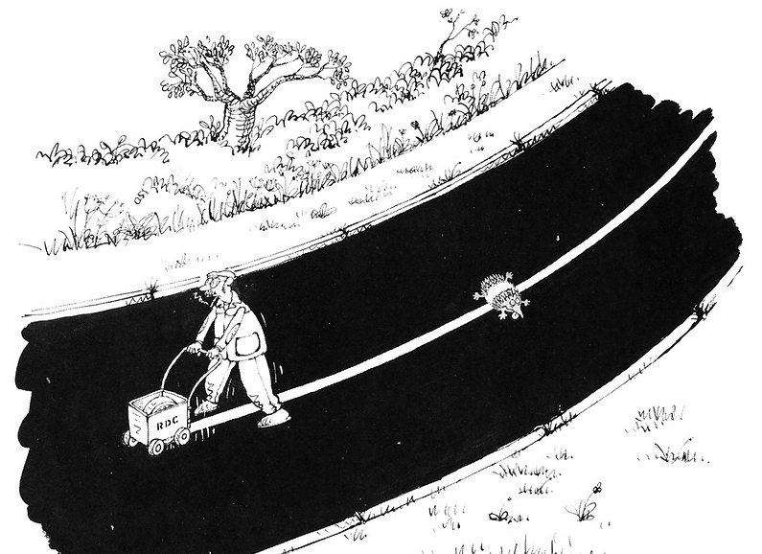

Answer:

