Book History

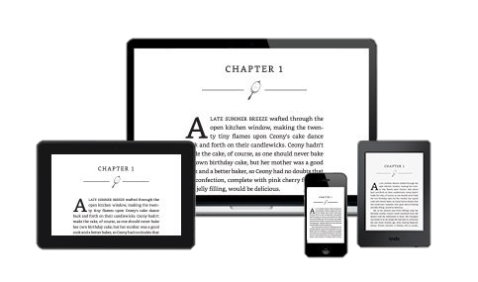
Tasks:

- Open a blank presentation.
- Choose a theme.
- On the title slide, add the text, “Book History” and your name and class as the subtitle.
- Add a Title and Content/Body slide for each of the 4 facts.
- Add the facts from this page into each slide of the presentation.
- Add transitions between slides.
- Add animations for the body text for each slide.
Book Facts
- Paper was first made in China around 200BC.
- The Romans were the first people to put pieces of manuscript between covers. This was much easier to read than scrolls.
- The first books were written by hand. With the inventions of carved wood block printing then the printing press, many more people could have books to read.
- E-book means electronic book. In the 2000s publishers began making books in digital for computers, tablets and smart phones.

extras:

tips:

- Choose a simple theme and remember to use colours that look good together.
- Use duplicate slide for your ‘4 facts’ slides.

- Add pictures to each slide that go with the fact.
- Add transitions between each slide.

