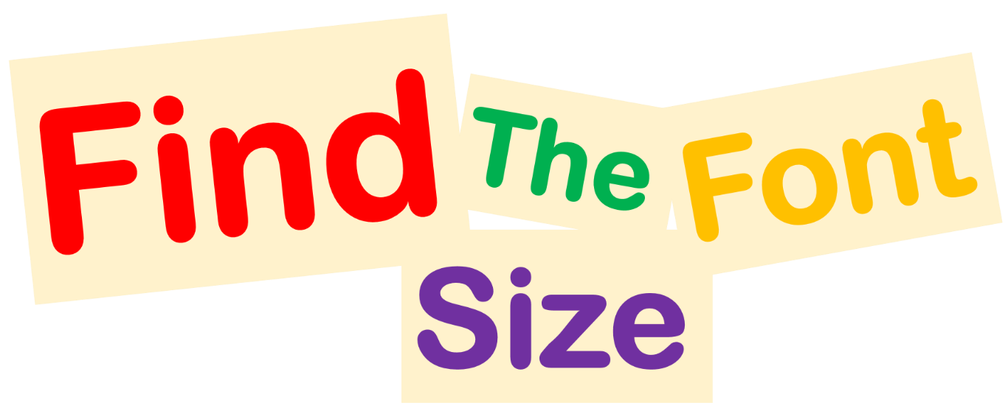

Using the Font Size Tool, highlight each word and change it to the correct size.

Fourteen

Eighteen

Twenty

Fifteen

Thirty Six

Sixteen

Twenty

Twenty Four

Thirty Two

Ten

