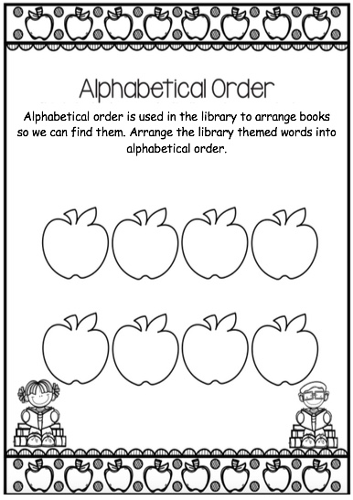

Name:_______________________ Class _______________

scan

friends

library

pencils

fiction

books

crayons

title