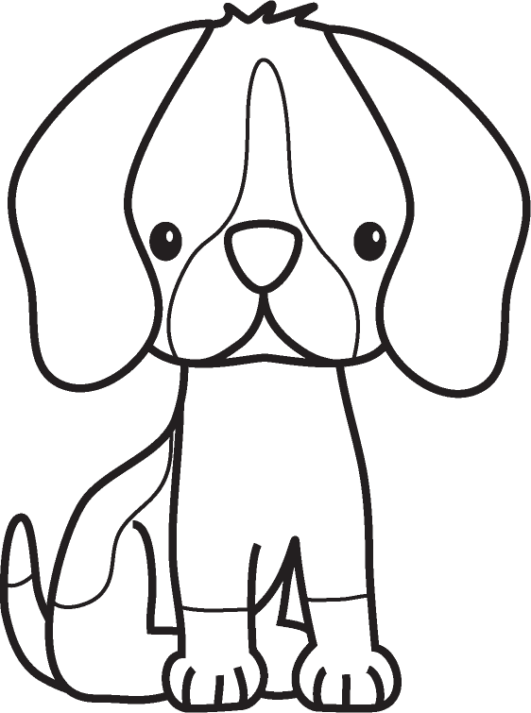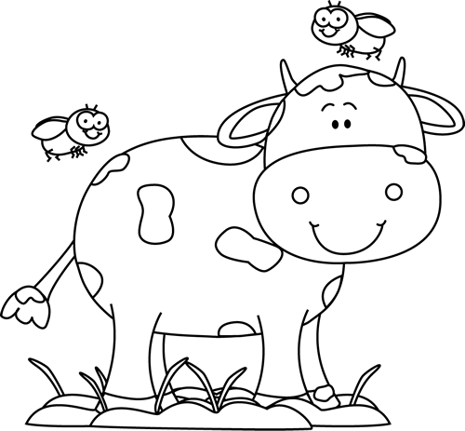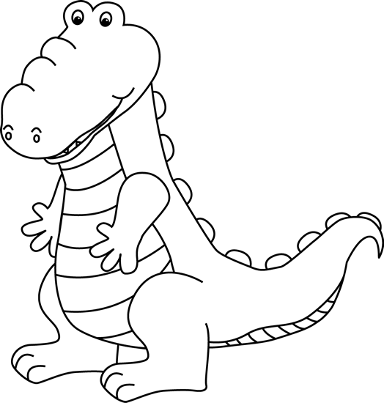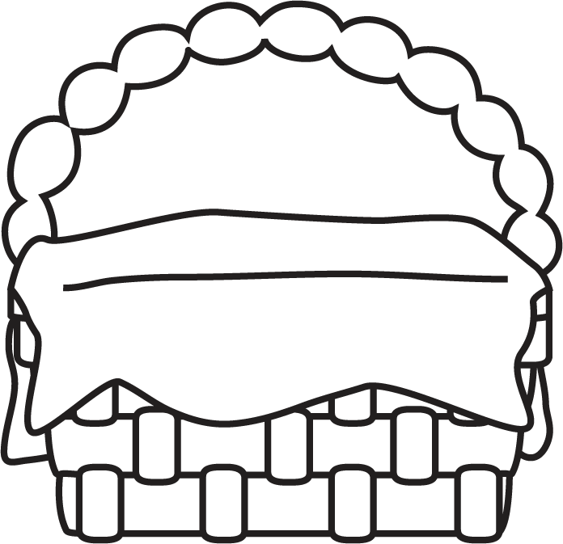

**Characteristics of Animal Fiction**

* Animals are the main characters.
* The animals behave like they could be real.
* The problem in the story is realistic for that kind of animal
* Animals sometimes use human speech.
* Humans often cause a problem for the animals.

Animal Fiction

**Author’s Purpose:**

**To entertain.**

**Some animal fiction stories I know are:**

**Keep track of the animal fiction you read here!**

**Name:___________________________**

**Good Readers Know About Genres**