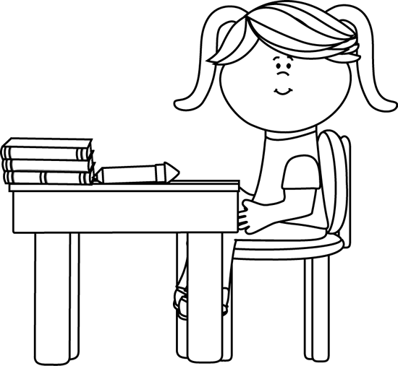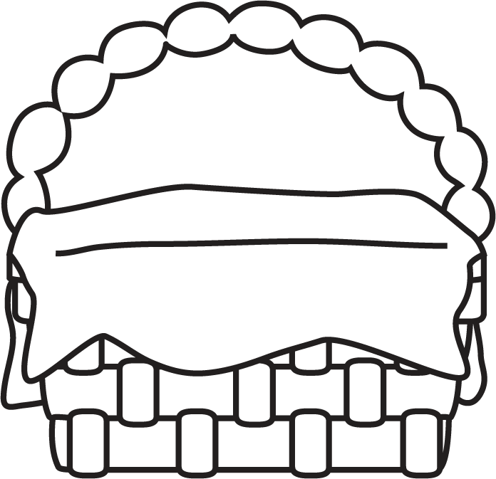

Autobiography

**Some autobiographies I know are:**

**Characteristics of Autobiography**

* The story of a real person’s life, told by that person.
* Told in time order.
* It has personal details about the person’s life.
* Usually, the person has done something special in their life.
* Includes personal photos or documents.
* Sometimes the details are not completely true – the person tells only the details and events they want to share, not the whole truth.

**Author’s Purpose:**

**To entertain and inform.**

**Keep track of the autobiographies you read here!**

**Name:___________________________**

**Good Readers Know About Genres**