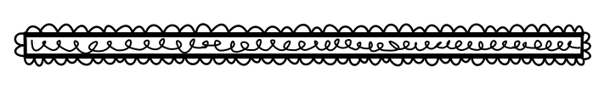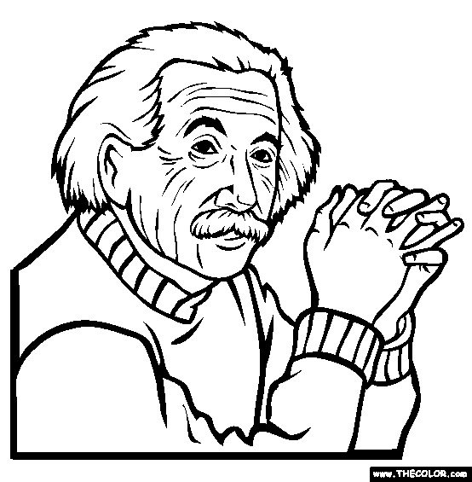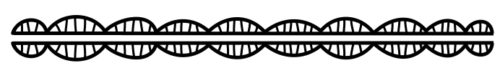

**Describe the person’s early life.**

**What can you learn from this person’s experiences?**

**Can she/he be a model in your life?**

Biography

**Who is the biography about?**

**What is the person famous for doing?**

**Tell an interesting fact about him/her?**

**Book Title:**

**Name:___________________________**

**My Little Activity Book About**