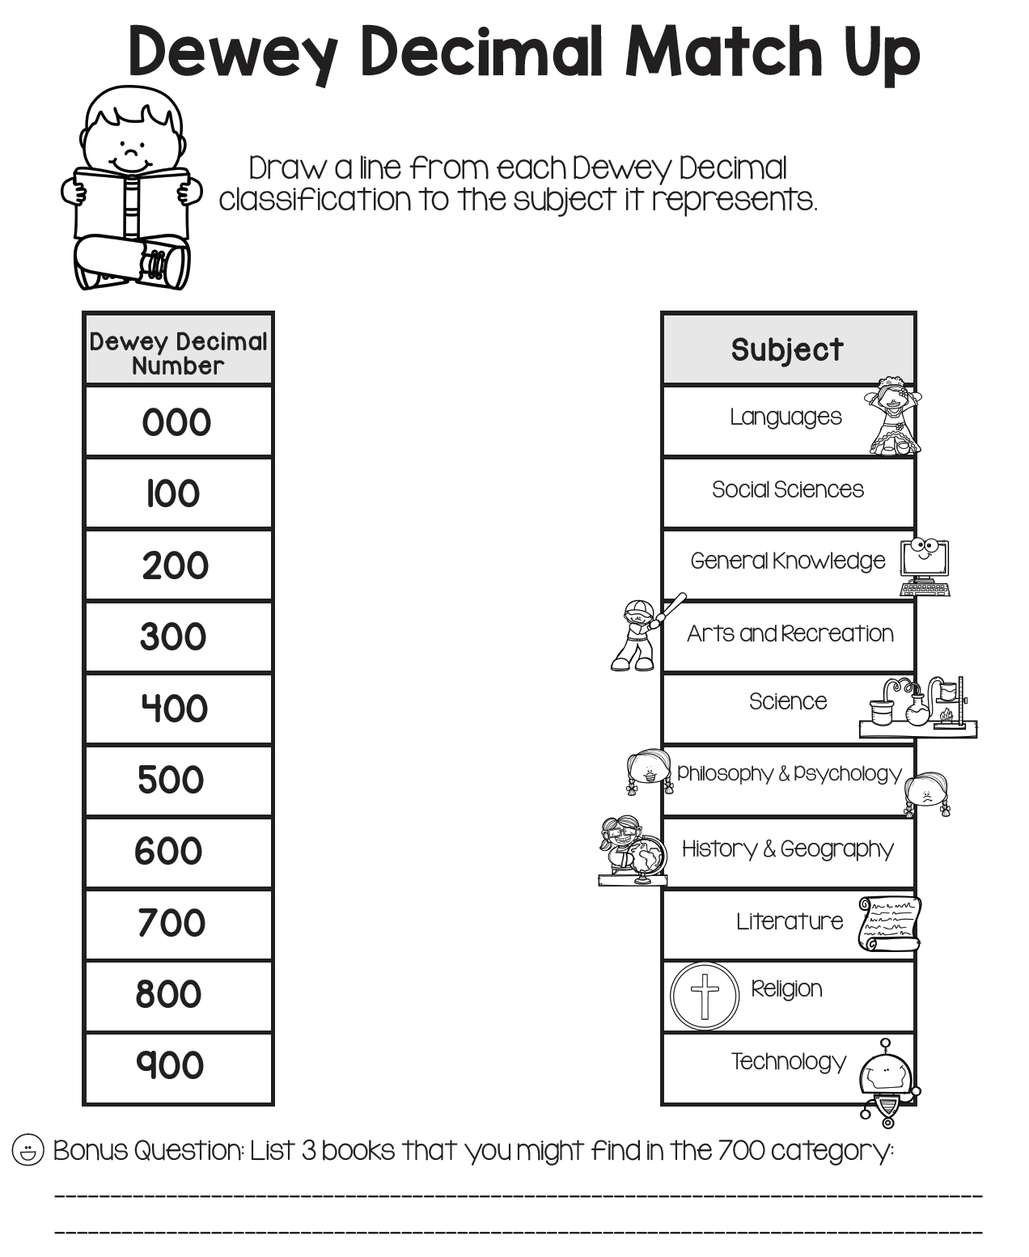

Name: ______________ Class: ­­­­­­­____________