

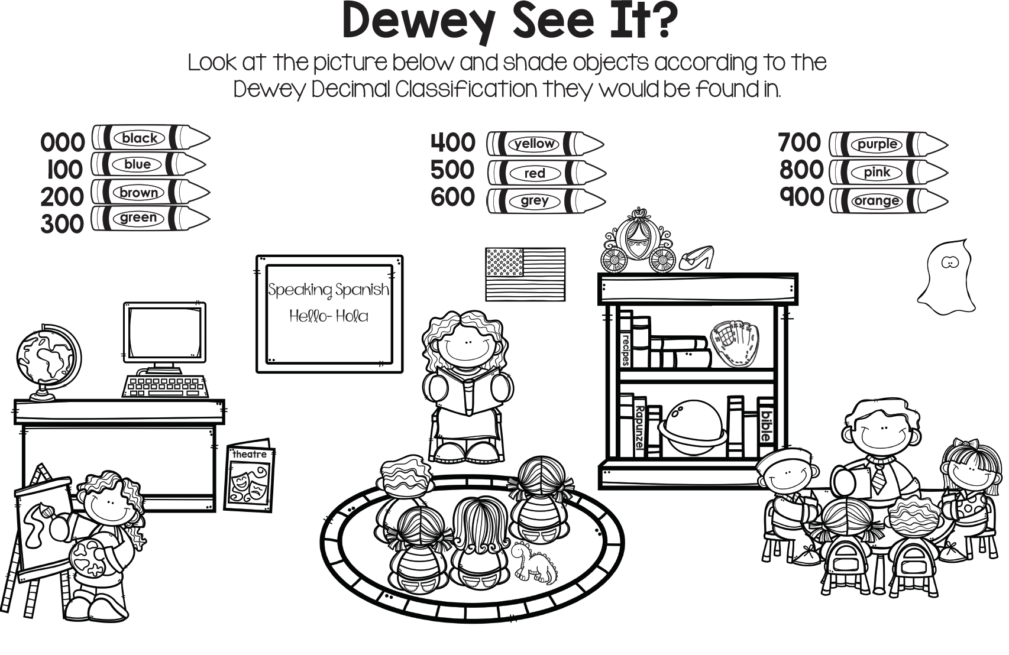

Name: ______________ Class: ­­­­­­­____________