Excel Blinky’s Spreadsheet

Blinky has made this spreadsheet.
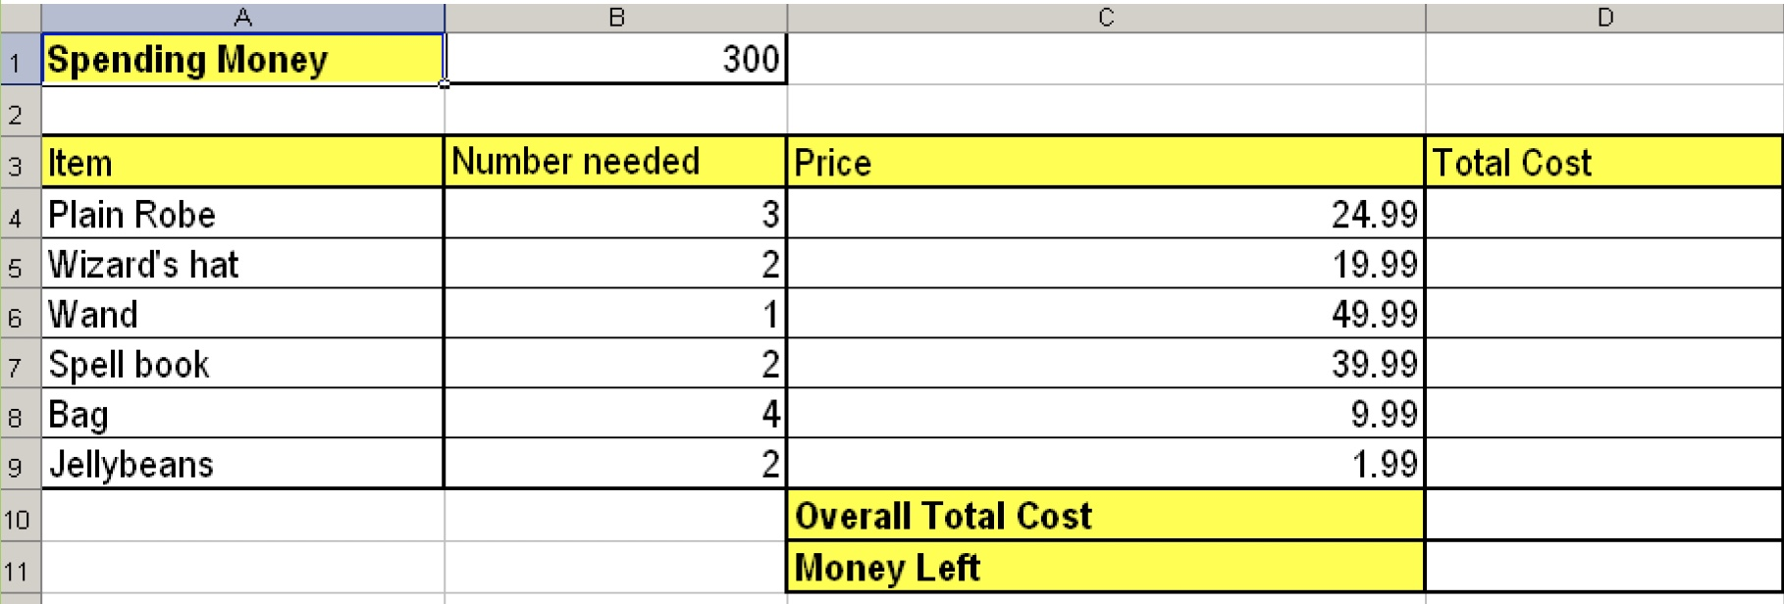

- What information does this spreadsheet show?

- Write down the formula that would be used in:

Cell D5 to calculate the Total Cost of Wizard’s hats

Cell D10 to calculate the Overall Total Cost

Cell D11 to calculate the Money Left

- In the spreadsheet above, a new row will be inserted above row 9 as Blinky now has to buy Frogs Legs as part of her shopping list. How will the formula in cell D10 change?
Write out the new formula in this box:

- Download Blinky’s Spreadsheet from Nuwarra Weebly and try your formulae.
Did it work first time YES NO.
Did you finally get it to work YES NO.

- Explain what work you did in today’s lesson.

- Albus Bumblebore has given Blinky the responsibility to set up an Ingredients Shop in one of the rooms in the school. Student will be able to buy ingredients for their potions during breaks 1 and 2. However, there are only 5 ingredients that can be sold in the shop at the moment as Albus is waiting for a delivery to arrive. These are the items currently available:

Ingredient Cost each
Bat ear | $ 1.99
Beard Hair | $ 0.05
Blood | $ 2.00
Eyeball (human) | $12.00
Feather | $ 0.10

The ingredients shop has been open for the past week and Blinky has managed to sell a lot of ingredients. The tally sheet shows how many of each ingredient has been sold each day as well as at the end of the week:
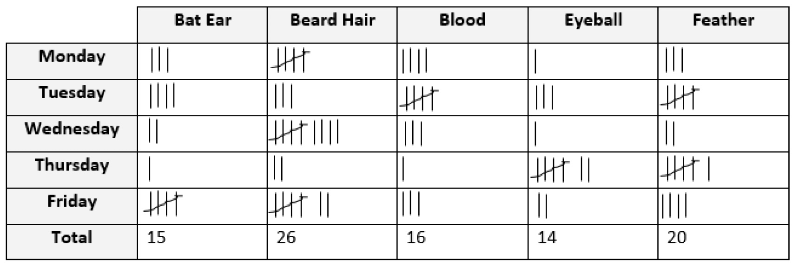

Albus has asked you to look at and read through all this information to design a spreadsheet to keep track of the money made on each item over the past week.

Design your spreadsheet (on the next page). Remember, your spreadsheet should include the following things:
- Title
- Suitable image
- Name of each ingredient
- Total number of each ingredient sold at the end of the week
- Price of each ingredient
- Total cost of the number of each ingredient sold (Hint: Consider writing a formula!)

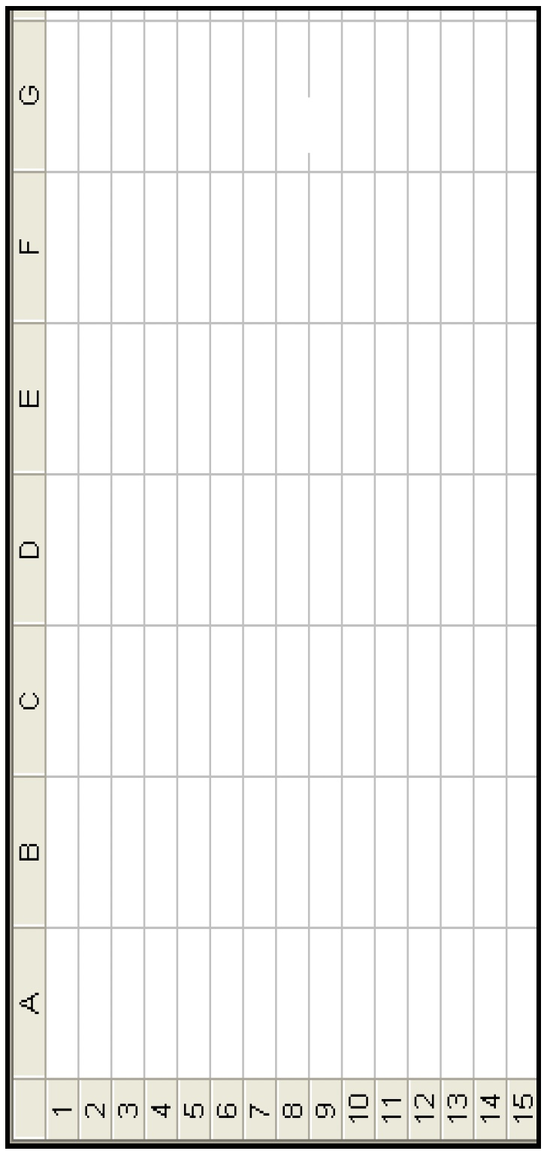

6. When your plan is complete, check with your teacher and create it on the computer

