Excel Test
Using the spreadsheet below write the correct formulae and cell addresses.

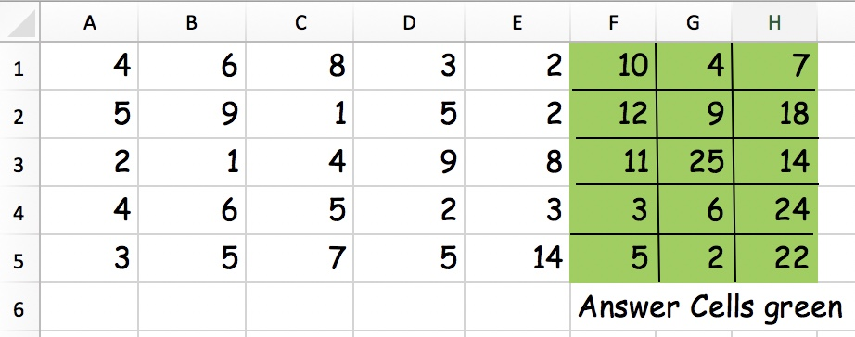

Cell Formula  reference |  | Which cell address would you put the formula in to give the correct answer?
A1 add B1
E5 add B5
A4 add C5
C3 subtract B3
D3 subtract A1
E3 subtract A4
D4 multiplied by E4
C5 multiplied by E1
A2 multiplied by B5
B2 divided by C2
C3 divided by A3
E7 divided by D4
= A1+A2+A3+A4+A5
(Write a better formula)
=A2+B2+C2+D2+E2
(Write a better formula)

