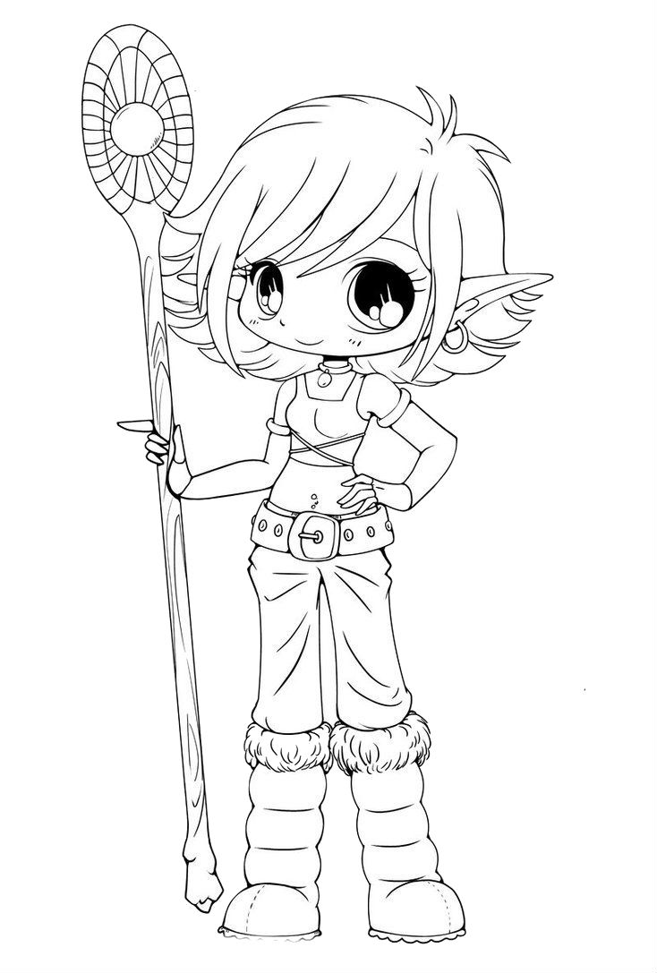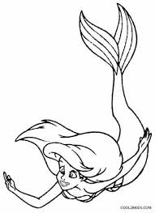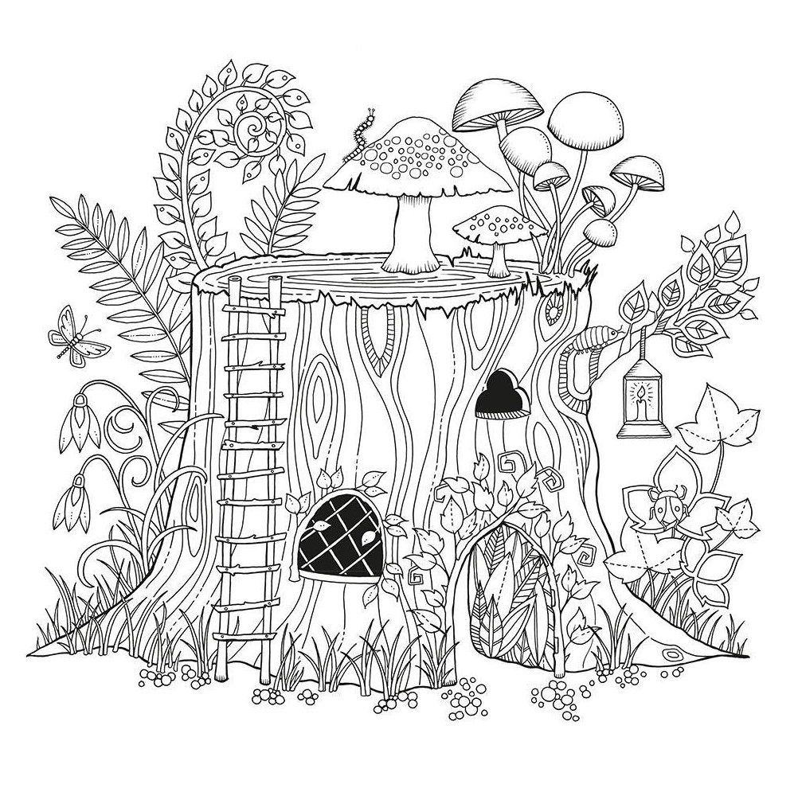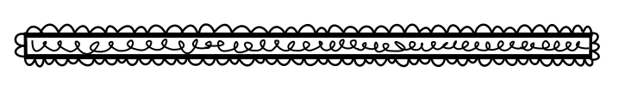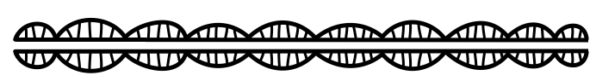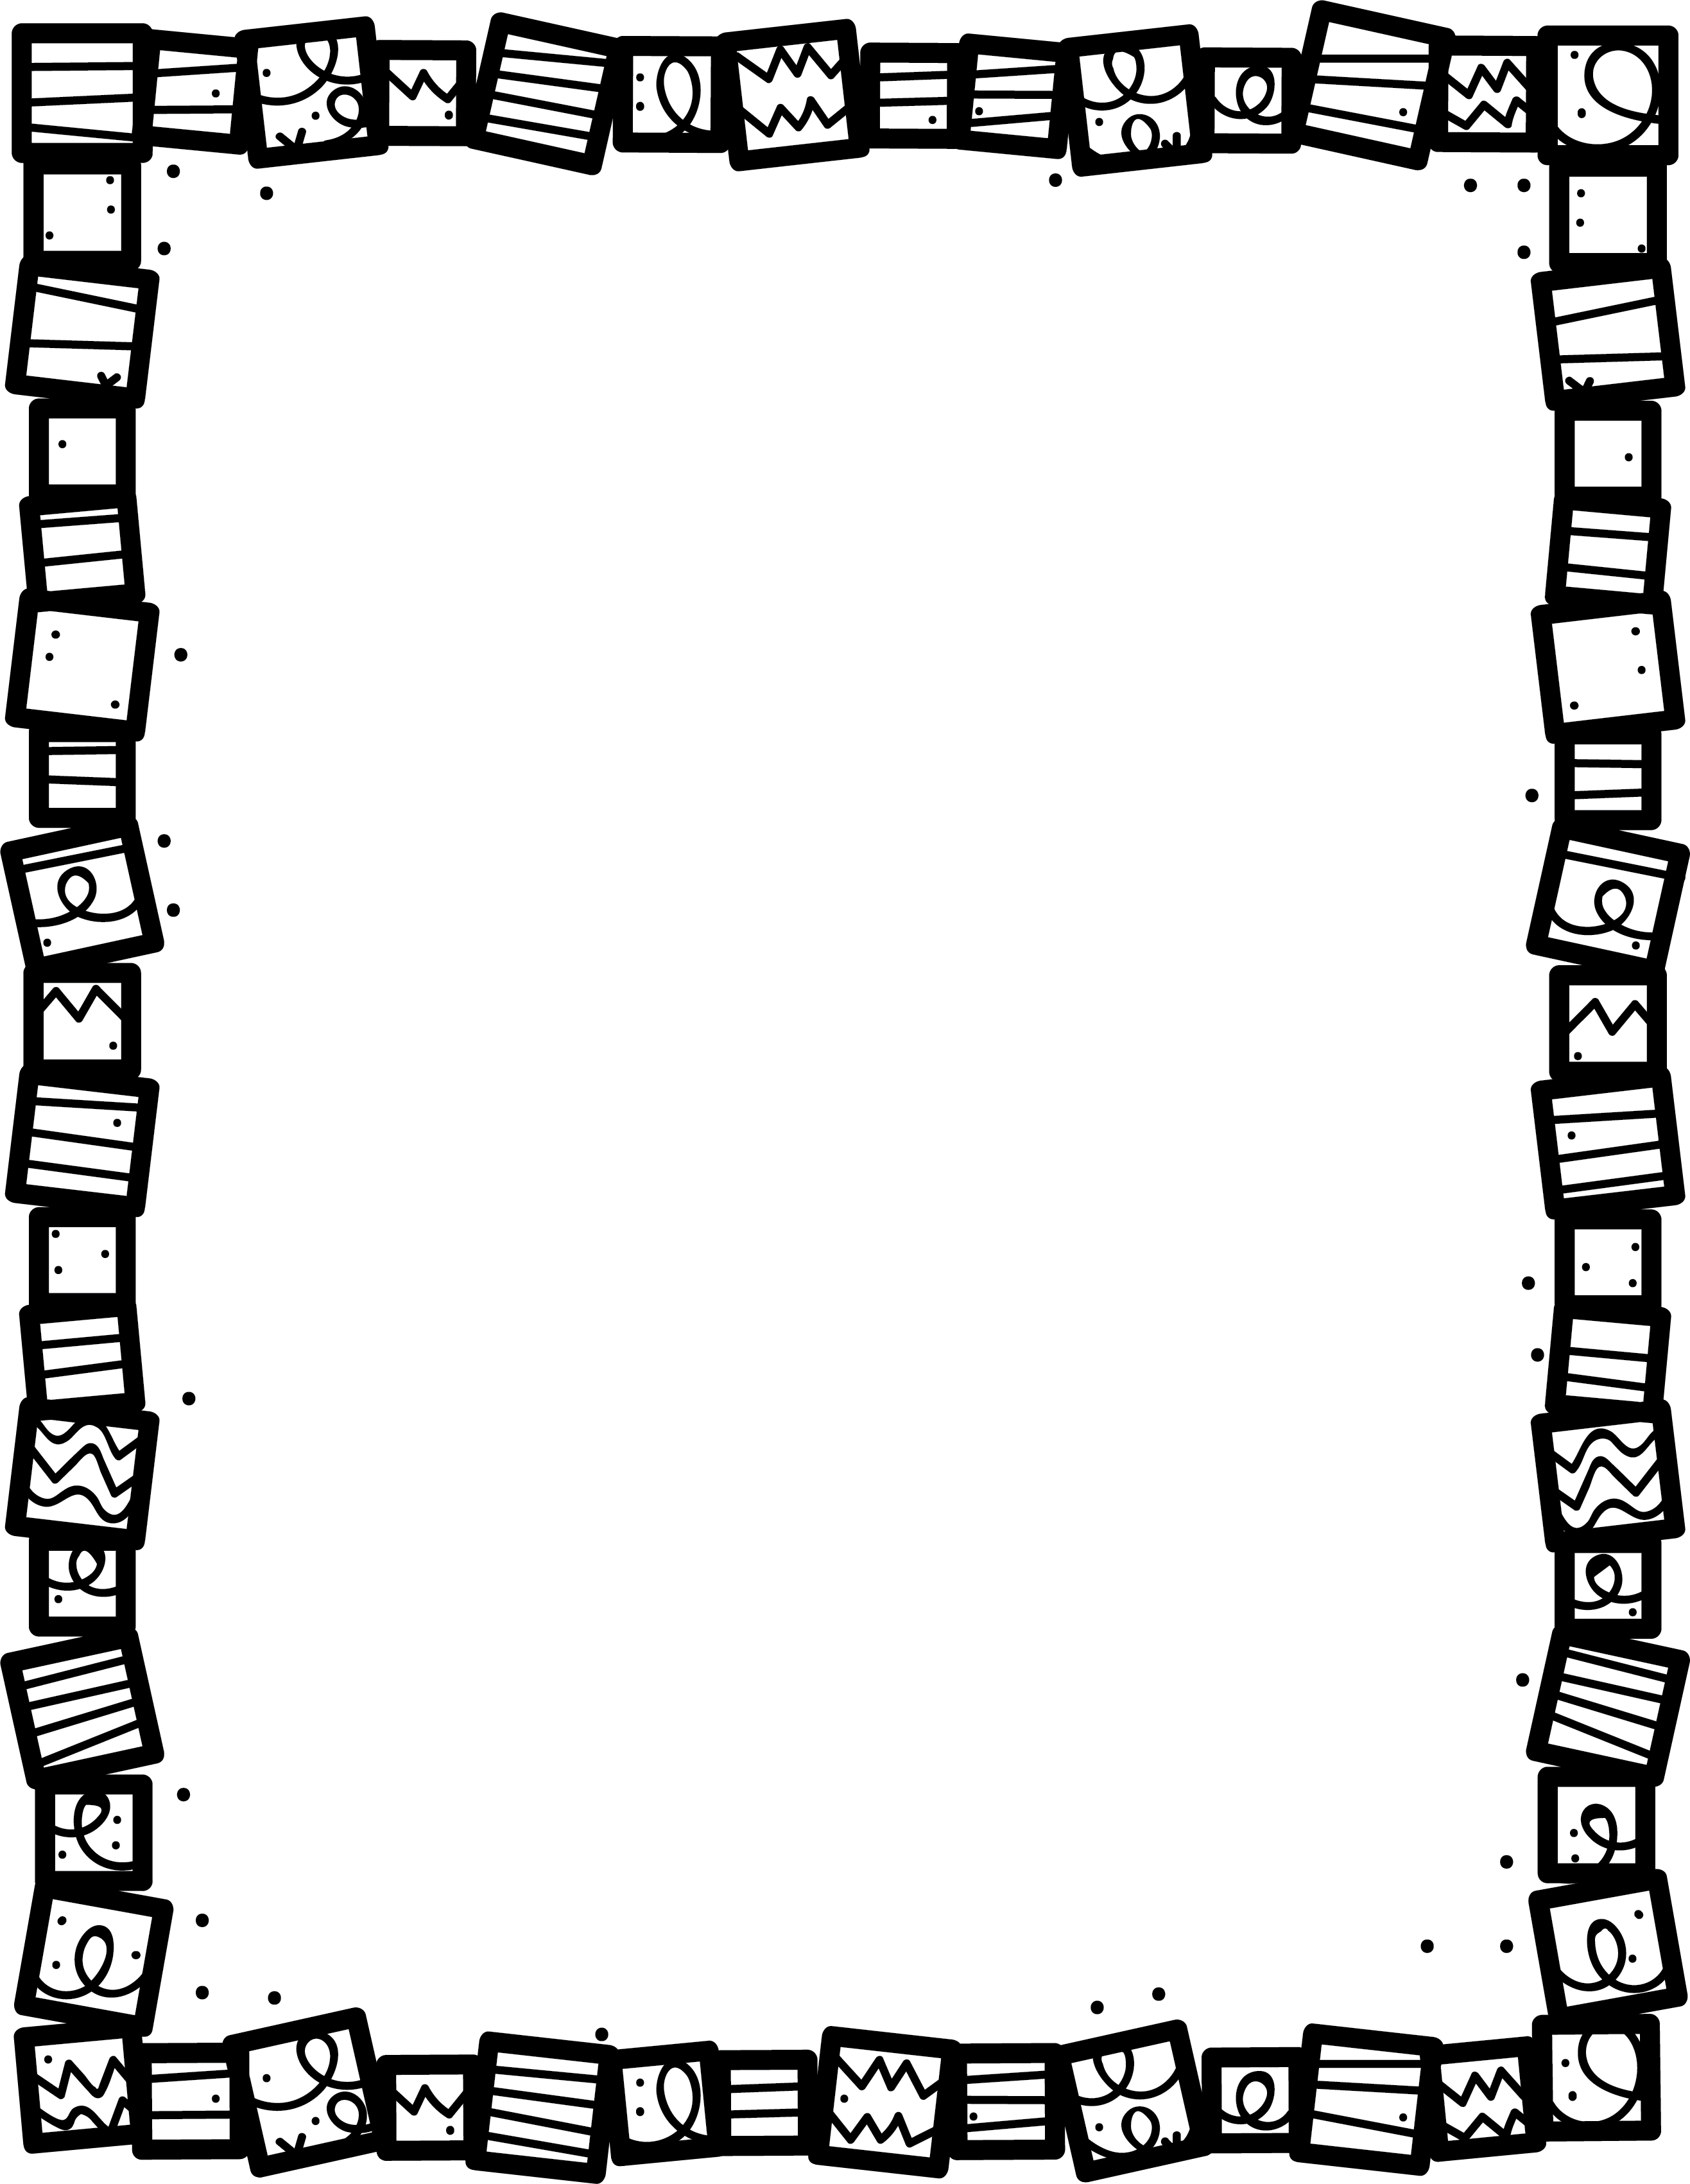

**What is the plot? Explain.**

Fantasy

**My Little Activity Book About**

**What magic do you see happening?**

**What was your favourite part? Why?**

**Describe the setting. What makes it unusual?**

**Is there a journey or quest in the story? Explain.**

**What is strange or magical about the characters?**

**Book Title:**

**Name:___________________________**