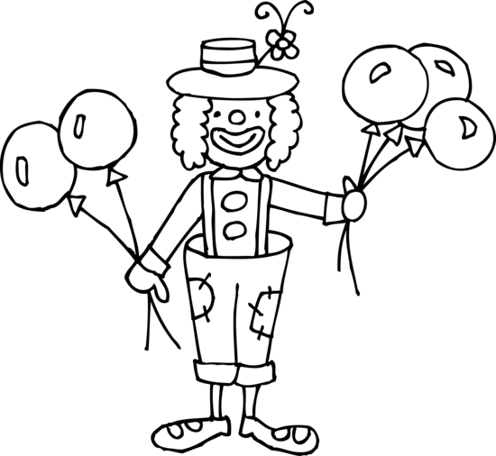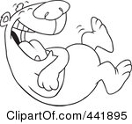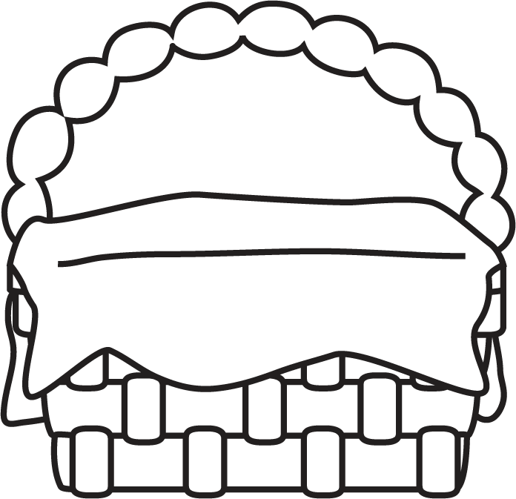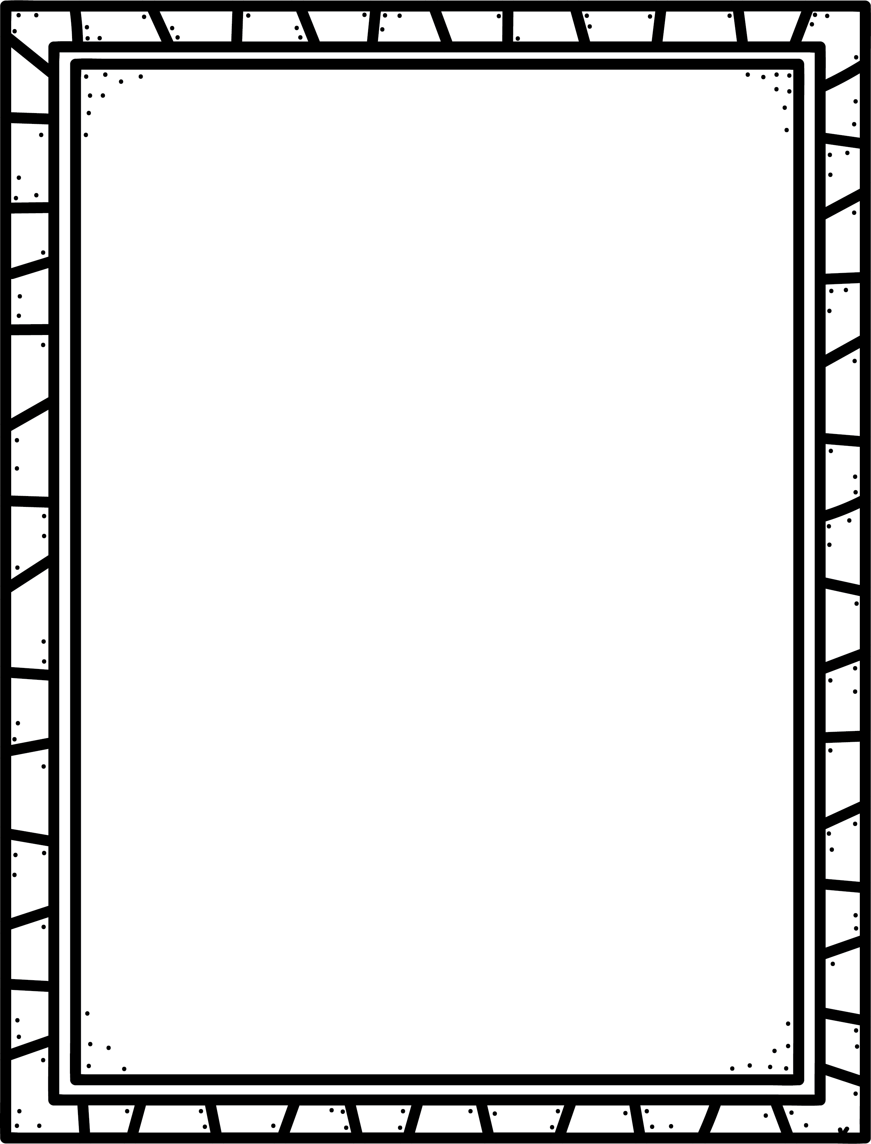

**Characteristics of Humour**

* Often realistic fiction with especially silly events and characters.
* The main goal is to make the reader laugh.
* Funny events – characters find themselves in strange or funny situations that could possibly happen in real life.

**Author’s Purpose:**

**To entertain**

**Some humorous stories I know are:**

**Keep track of the humorous novels you read here!**

**Name:___________________________**

Humour

**Good Readers Know About Genres**