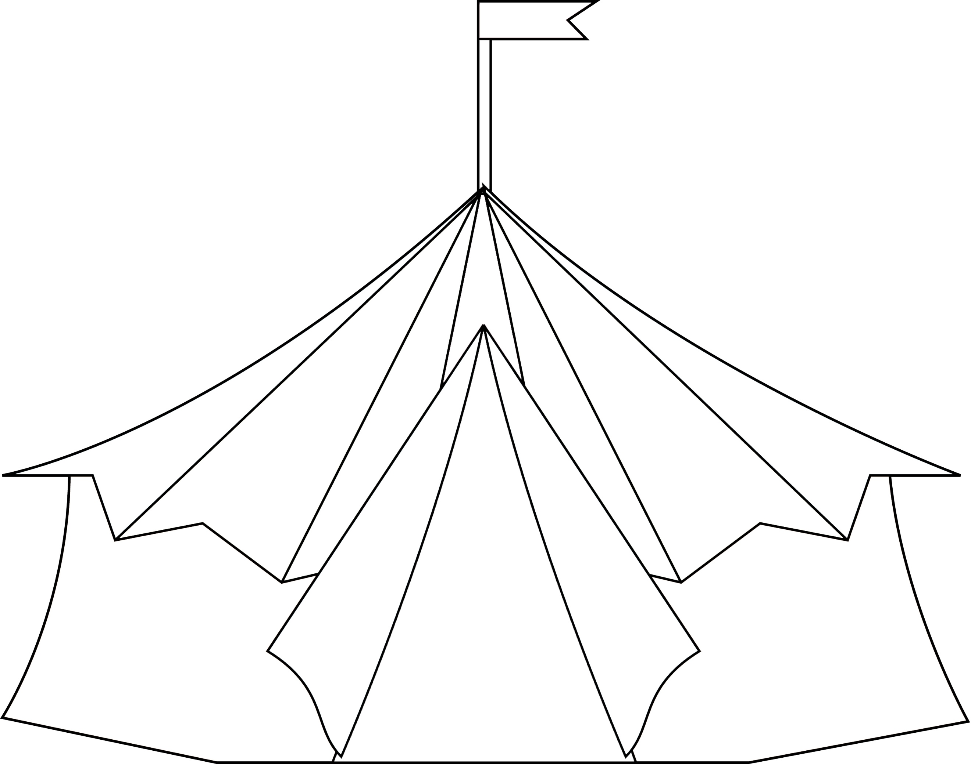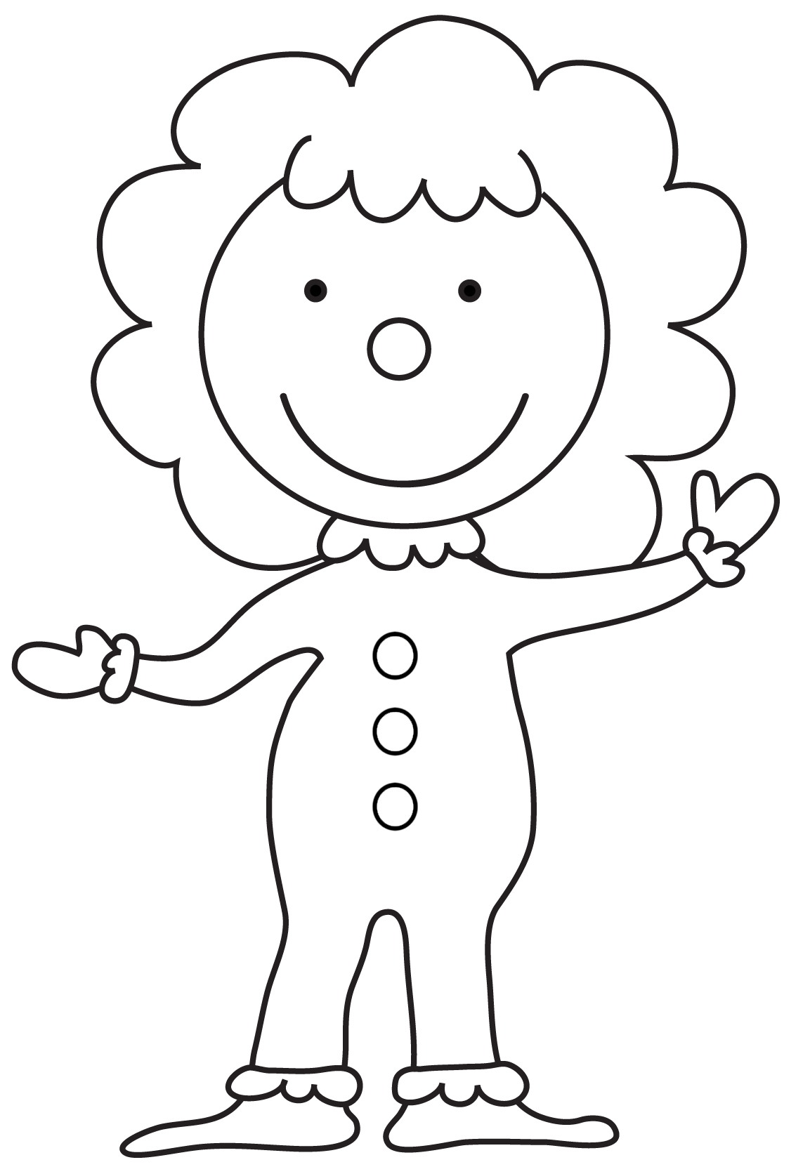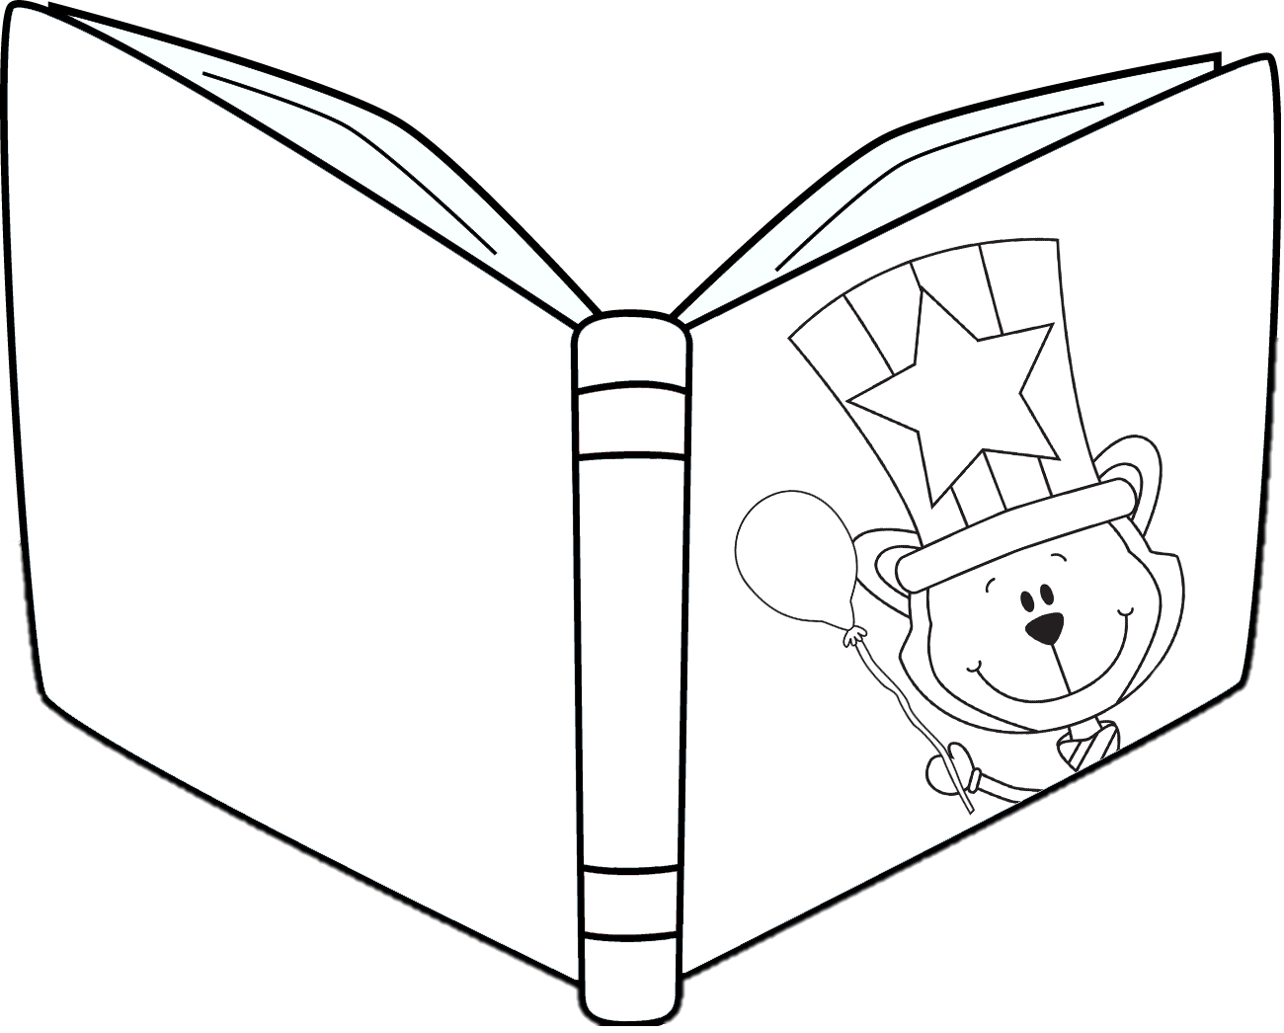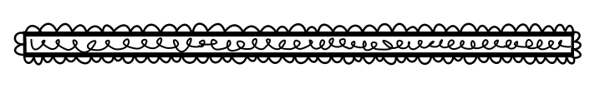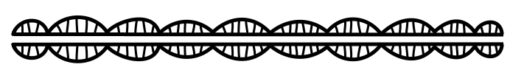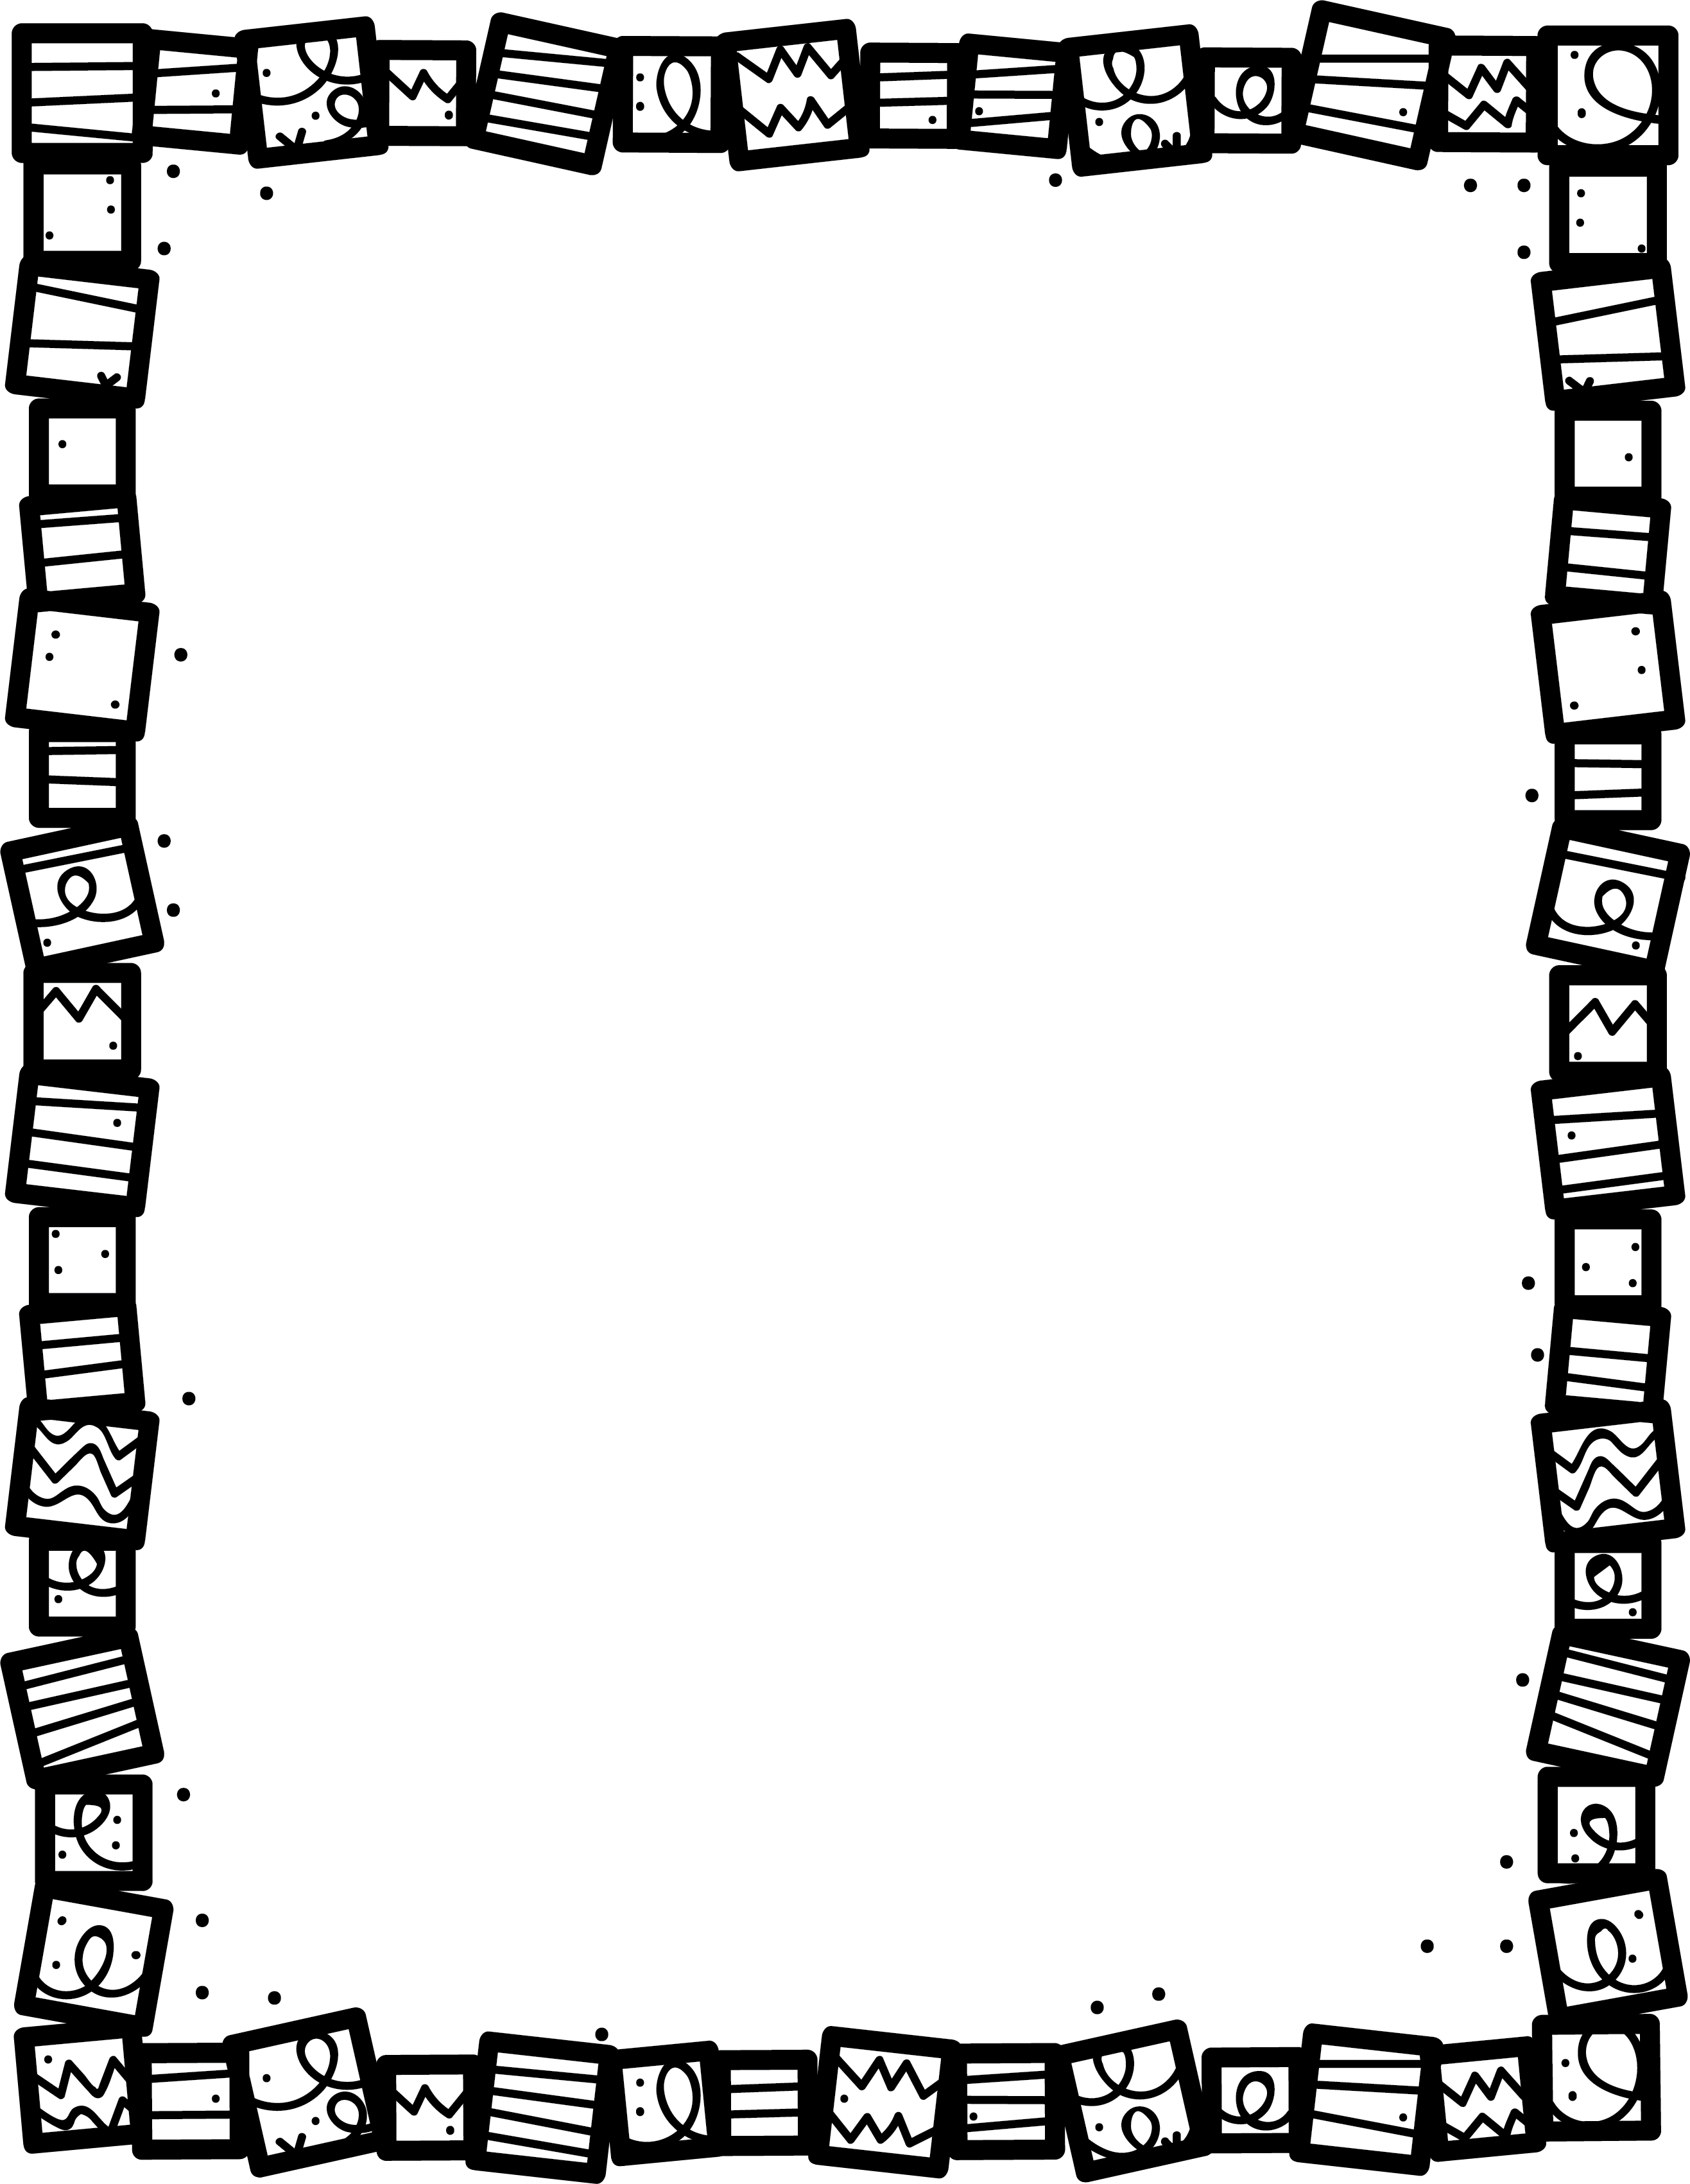

**What makes the main character silly sometimes?**

**What part is the funniest? Why?**

**What character is funniest? Explain.**

**What are some of the funniest events?**

**Is the setting out of the ordinary?**

**Could they really happen? Explain.**

**Book Title:**

**Name:___________________________**

**My Little Activity Book About**

Humour Stories