Name: Class:

It’s Just Cricket!
Place these names in alphabetical order and number them from 1 to 22.
Richardson, Patterson, Harris, Labuschagne, Head, Bancroft, Cartwright, Renshaw, Maddinson, Handscomb, Siddle, Hazlewood, Marsh, Agar, Lyon, Wade, Warner, Starc, Smith, Paine, Cummins, Pattinson.

Team 1 Batting Order: 18, 17, 4, 8, 16, 20, 1, 5, 7, 14, 13.
Team 2 Batting Order: 21, 6, 3, 10, 2, 9, 15, 22, 12, 11, 19.

Team 1 Batting order names:

Team 2 Batting order names:

Scoreboard
Brisbane First Test 1st Innings Team 1
 | Batsman | How Out |  | Bowler | Score
18 |  | cgt 3 | 11 |  | 35
17 |  | cgt 15 | 12 |  | 56
4 |  | LBW | 12 |  | 29
8 |  | bowled | 19 |  | 145
16 |  | std 15 | 22 |  | 189
20 |  | cgt 8 | 11 |  | 78
1 |  | bowled | 12 |  | 3
5 |  | cgt 6 | 11 |  | 47
7 |  | cgt 2 | 19 |  | 1
14 |  | NOT OUT |  |  | 4
13 |  | cgt 10 | 22 |  | 17
BYES 3 LEG BYES 7 NO BALLS 30 WIDES 5 TOTAL SUNDRIES 45
TOTAL SCORE 649

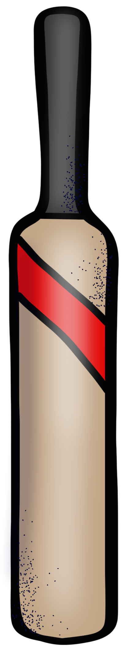
 | Bowling
 | Bowler | Overs | Maidens | Runs | Wickets
12 |  | 40 | 4 | 125 | 3
11 |  | 45 | 3 | 134 | 2
19 |  | 35 | 2 | 146 | 2
22 |  | 50 | 10 | 140 | 2
3 |  | 8 | 3 | 30 | 0
2 |  | 4 | 0 | 29 | 0

Scoreboard
Brisbane First Test 1st Innings Team 2
 | Batsman | How Out |  | Bowler | Score
21 |  | bowled | 13 |  | 3
6 |  | cgt 17 | 5 |  | 4
3 |  | cgt 18 | 5 |  | 46
10 |  | LBW | 14 |  | 12
2 |  | cgt 1 | 13 |  | 37
9 |  | cgt 16 | 14 |  | 0
15 |  | cgt 16 | 13 |  | 0
22 |  | bowled | 5 |  | 7
12 |  | LBW | 13 |  | 10
11 |  | cgt 13 | 13 |  | 5
19 |  | NOT OUT |  |  | 1
BYES 0 LEG BYES 0 NO BALLS 2 WIDES 0 TOTAL SUNDRIES 2
TOTAL SCORE 127

 | Bowling
 | Bowler | Overs | Maidens | Runs | Wickets
13 |  | 20 | 6 | 50 | 5
14 |  | 12 | 2 | 38 | 2
5 |  | 11 | 2 | 29 | 3
1 |  | 4 | 1 | 8 | 0

Scoreboard
Brisbane First Test 2nd Innings Team 2
 | Batsman | How Out |  | Bowler | Score
21 |  | cgt 17 | 14 |  | 18
6 |  | cgt 7 | 13 |  | 25
3 |  | cgt 8 | 5 |  | 37
10 |  | RUN OUT |  |  | 0
2 |  | cgt 8 | 1 |  | 67
9 |  | cgt 16 | 1 |  | 43
15 |  | cgt 14 | 16 |  | 0
22 |  | cgt & bowled | 16 |  | 12
12 |  | cgt 18 | 1 |  | 6
11 |  | NOT OUT |  |  | 5
19 |  | cgt 16 | 16 |  | 4
BYES 1 LEG BYES 1 NO BALLS 3 WIDES 0 TOTAL SUNDRIES 5
TOTAL SCORE 222

 | Bowling
 | Bowler | Overs | Maidens | Runs | Wickets
14 |  | 15 | 3 | 37 | 1
5 |  | 14 | 2 | 36 | 1
1 |  | 20 | 3 | 61 | 3
16 |  | 13 | 2 | 40 | 3
13 |  | 15 | 1 | 43 | 1

The result of the Test is that Team won by an innings and runs.

