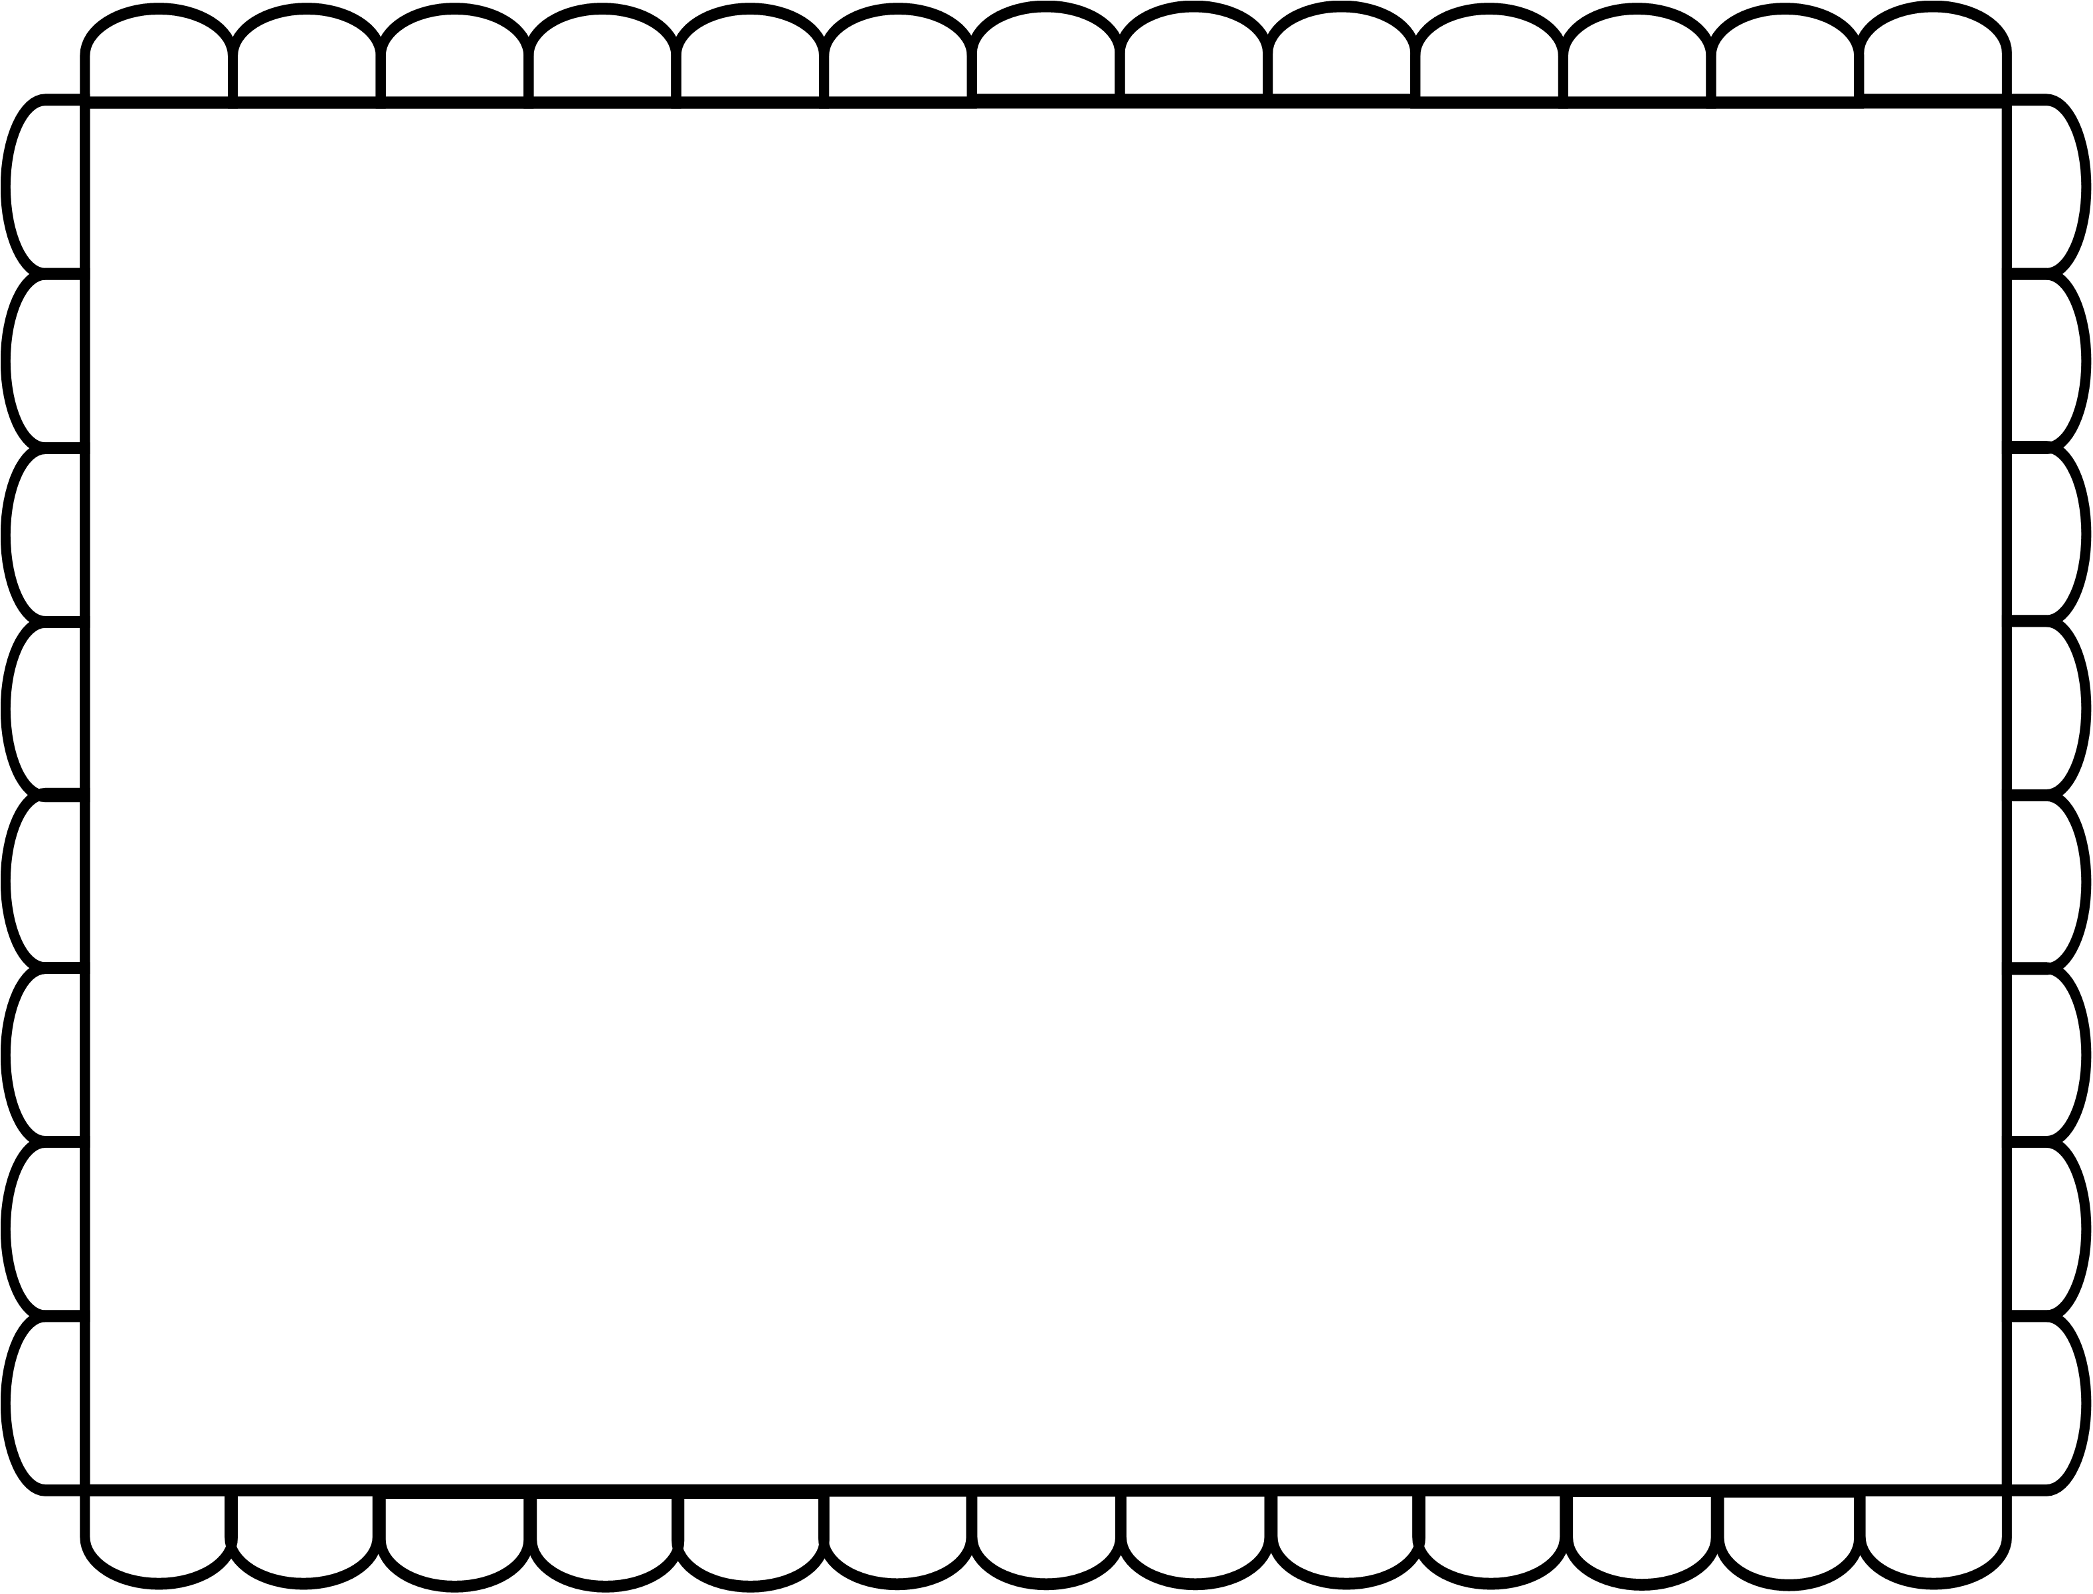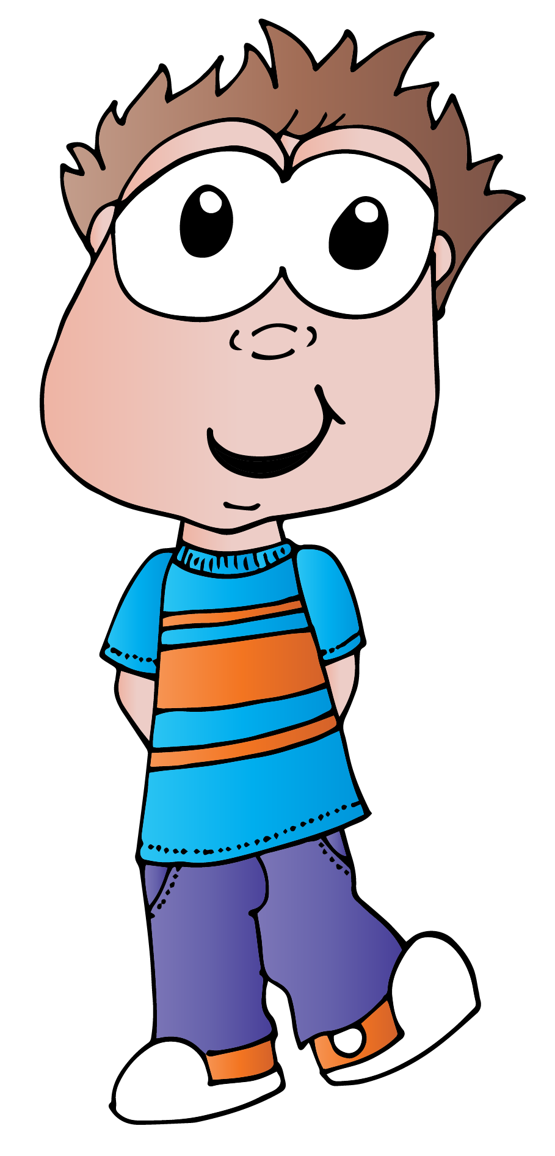

**Josh eats an apple.**

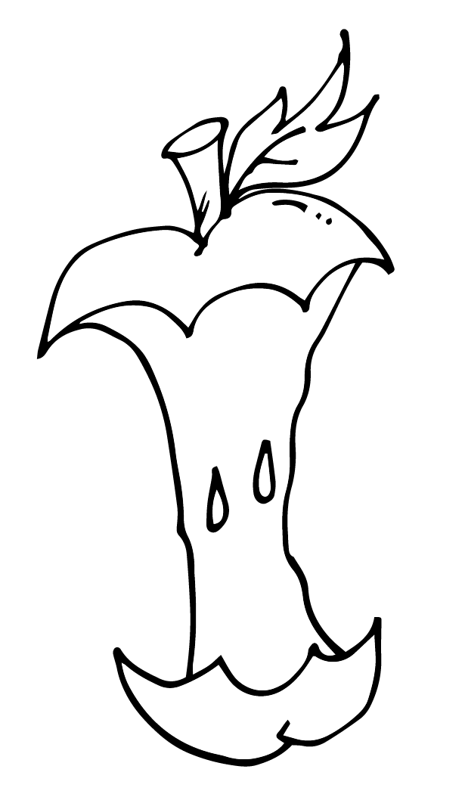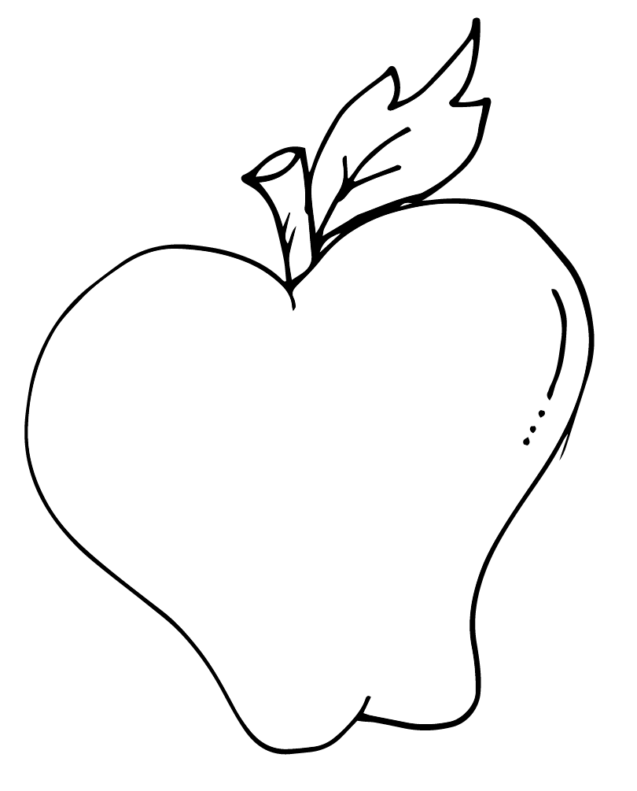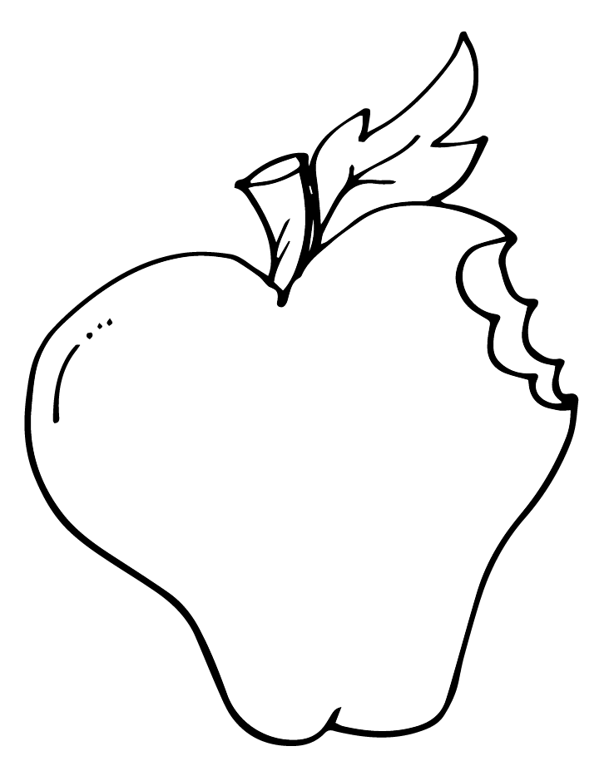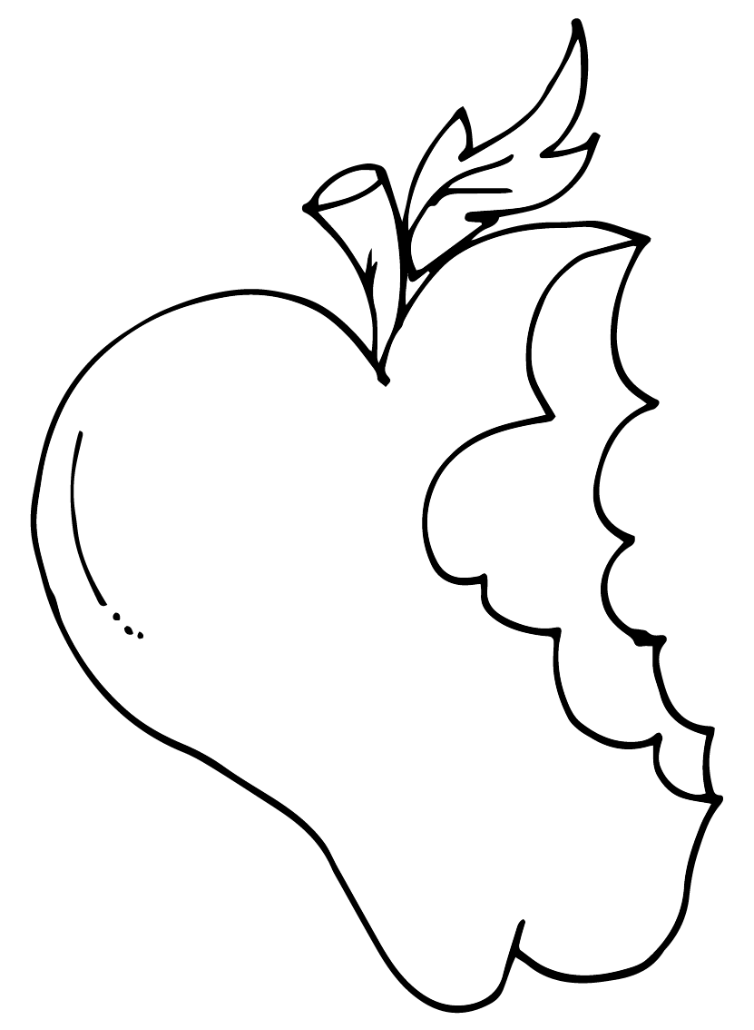

|  |  |  |  |
| --- | --- | --- | --- |
|  |  |  |  |

1. First, Josh gets an apple.
2. Next, he takes a bite.
3. Then, he takes several more bites.
4. Finally, he finishes the apple.