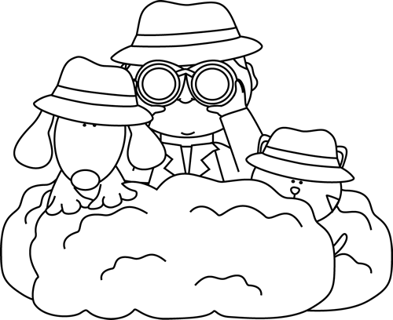

**Characteristics of Mysteries**

* Usually have q missing person, an object, a crime, or a puzzling event.
* Has clues about the event.
* The main character is the detective.
* The suspense keeps us wondering what will happen next.
* Often there are hidden clues that are important but don’t seem to be.
* Sometimes there are ‘red herrings’ – details that make you think the wrong thing.

Mystery

**Good Readers Know About Genres**

**Some mystery stories or series I know are:**

**Author’s Purpose:**

**To entertain**

**Keep track of the mystery stories you read here!**

**Name:___________________________**