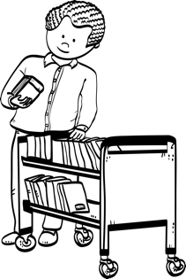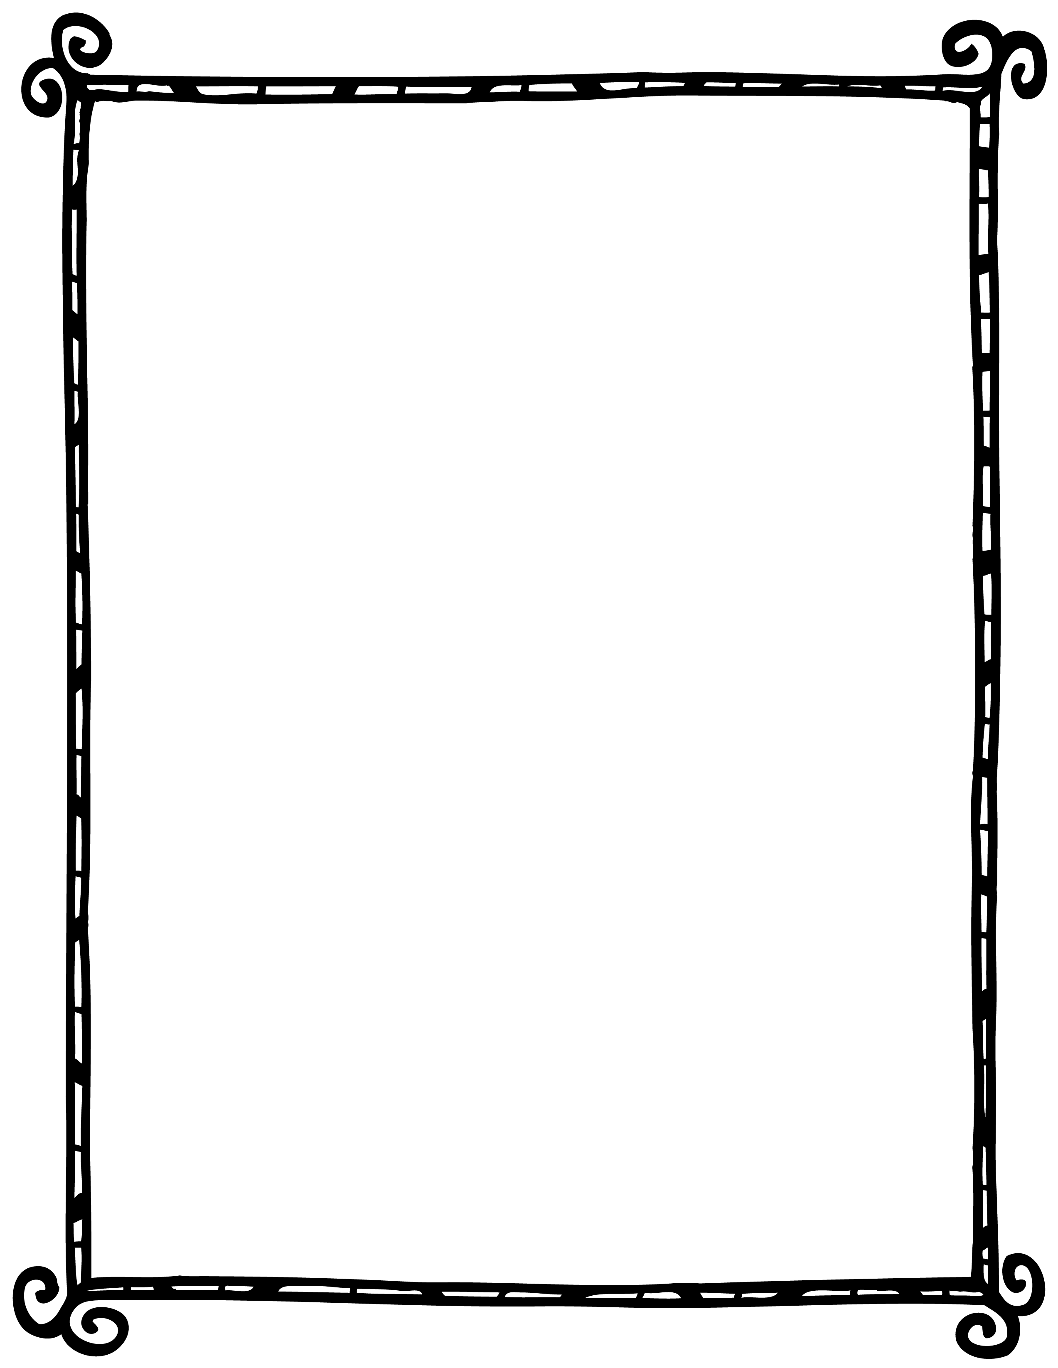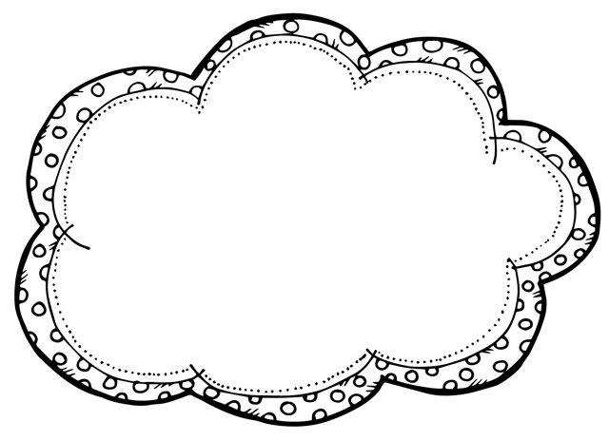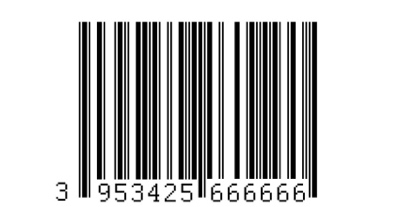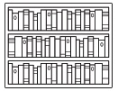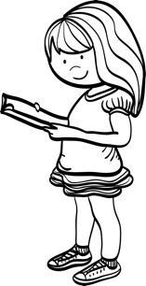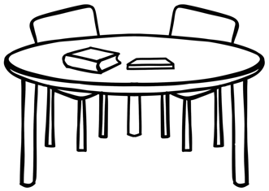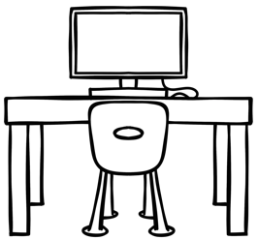kk

**b**

**t**

**l**

**t**

**s**

**c**

**l**

**l**

**b**

**r**

**b**

**s**

**b**

**l**

**l**

Words

barcode

table

computer

book

book shelf

reading

book trolley

librarian

spine label

**Name the Object**

Name:_____________________

Class: _____________________