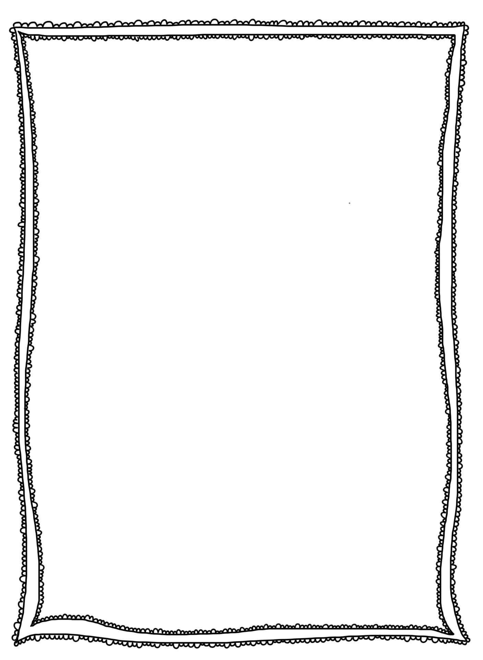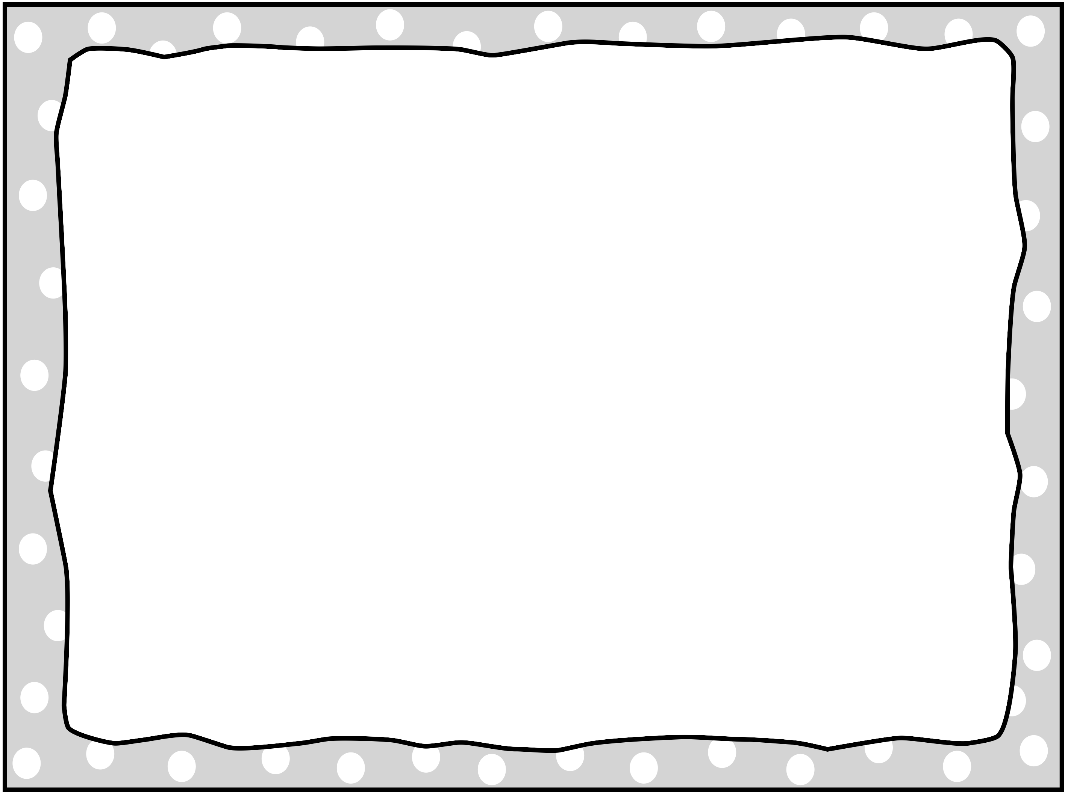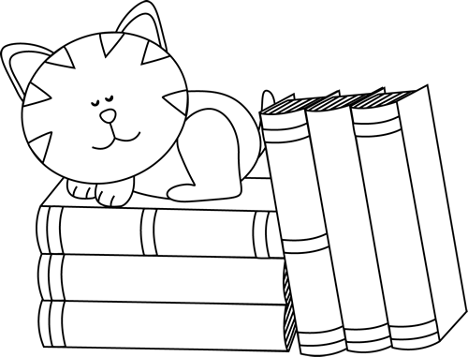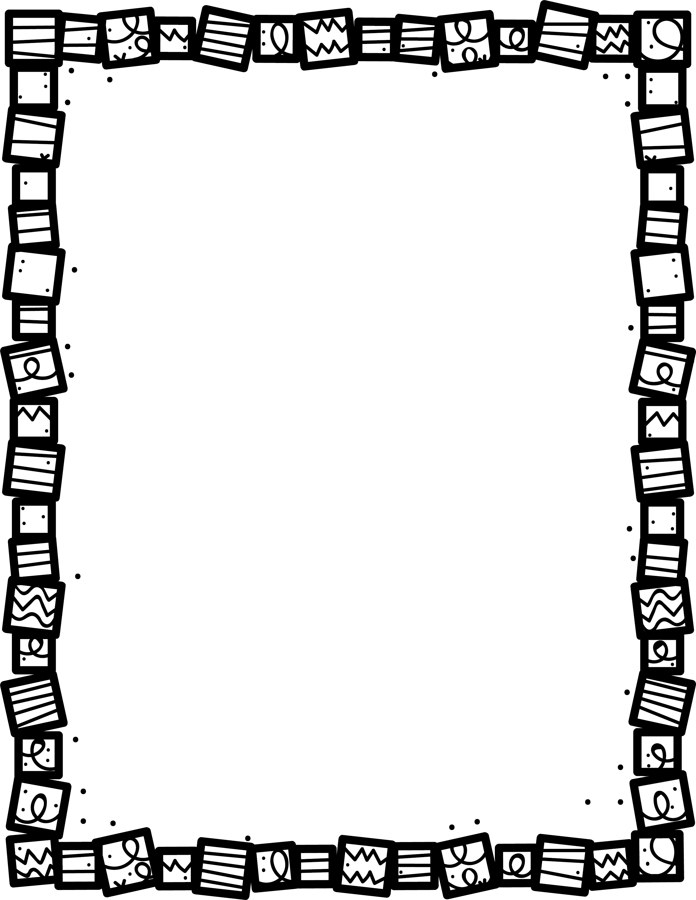

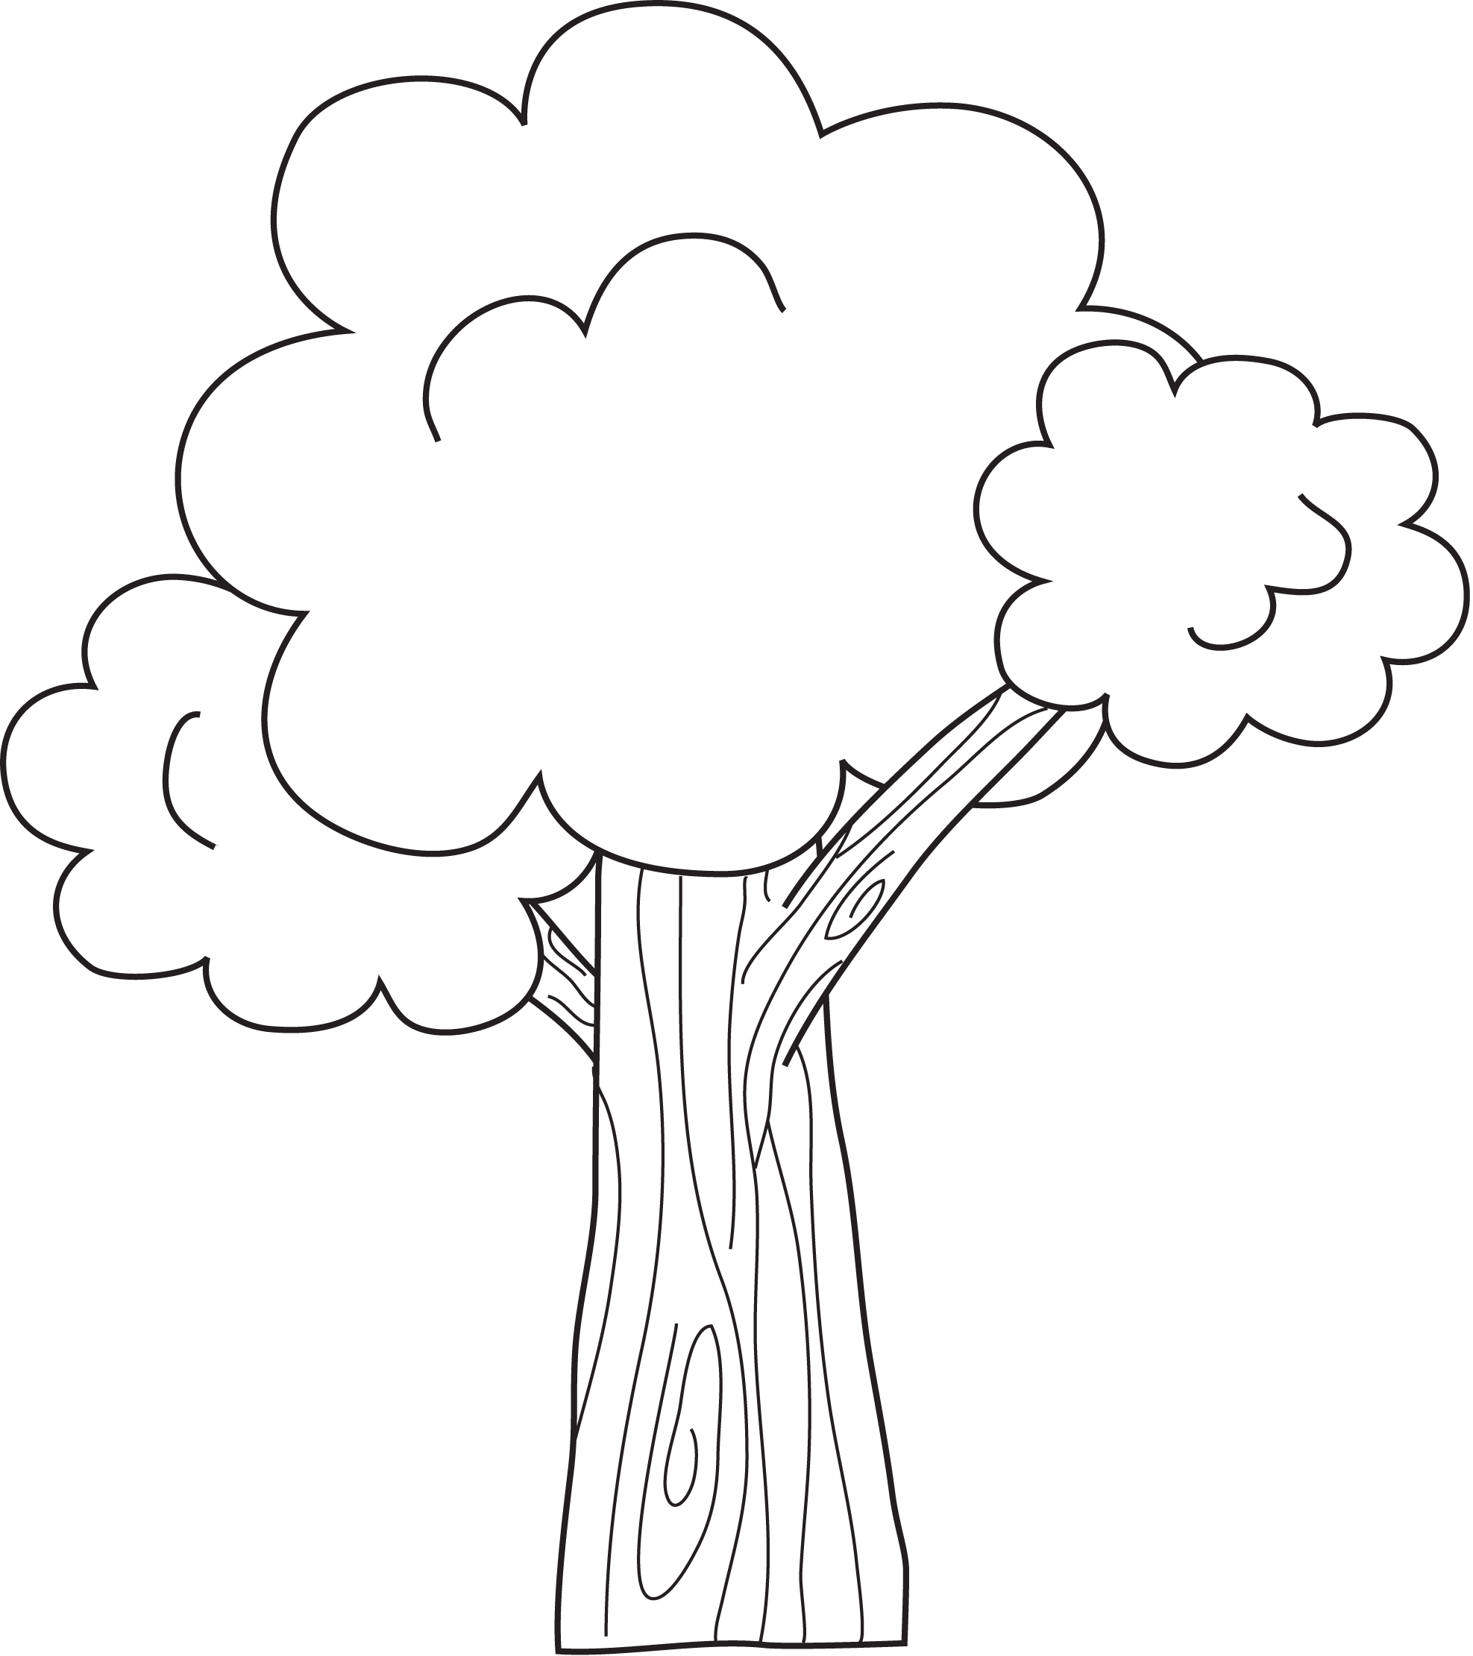

**Describe the main character.**

**Describe the setting. Why is it important to the story?**

**Can you tell the story with only the pictures? Explain.**

**What was your favourite part? Why?.**

**What is the plot? Explain.**

**Book Title:**

**Name:___________________________**

**My Little Activity Book About**

**What is the character’s problem?**

Picture

Books