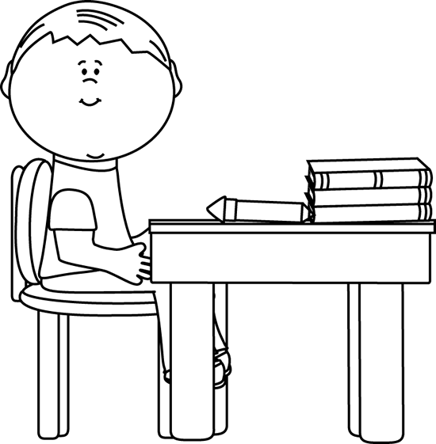

**Tell an interesting fact about him/her.**

**Describes the person’s early life.**

Autobiographies

**Who is the autobiography about?**

**What can you learn from this person’s experiences? Can he/she be a model for your life?**

**What is the person famous for doing?**

**Book Title:**

**Name:___________________________**

**My Little Activity Book About**