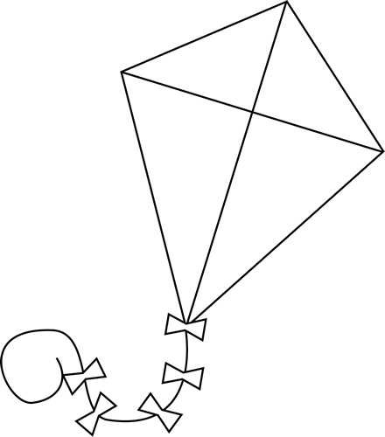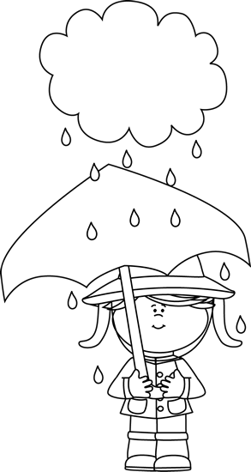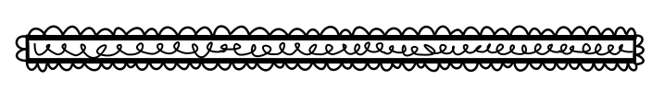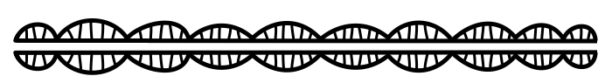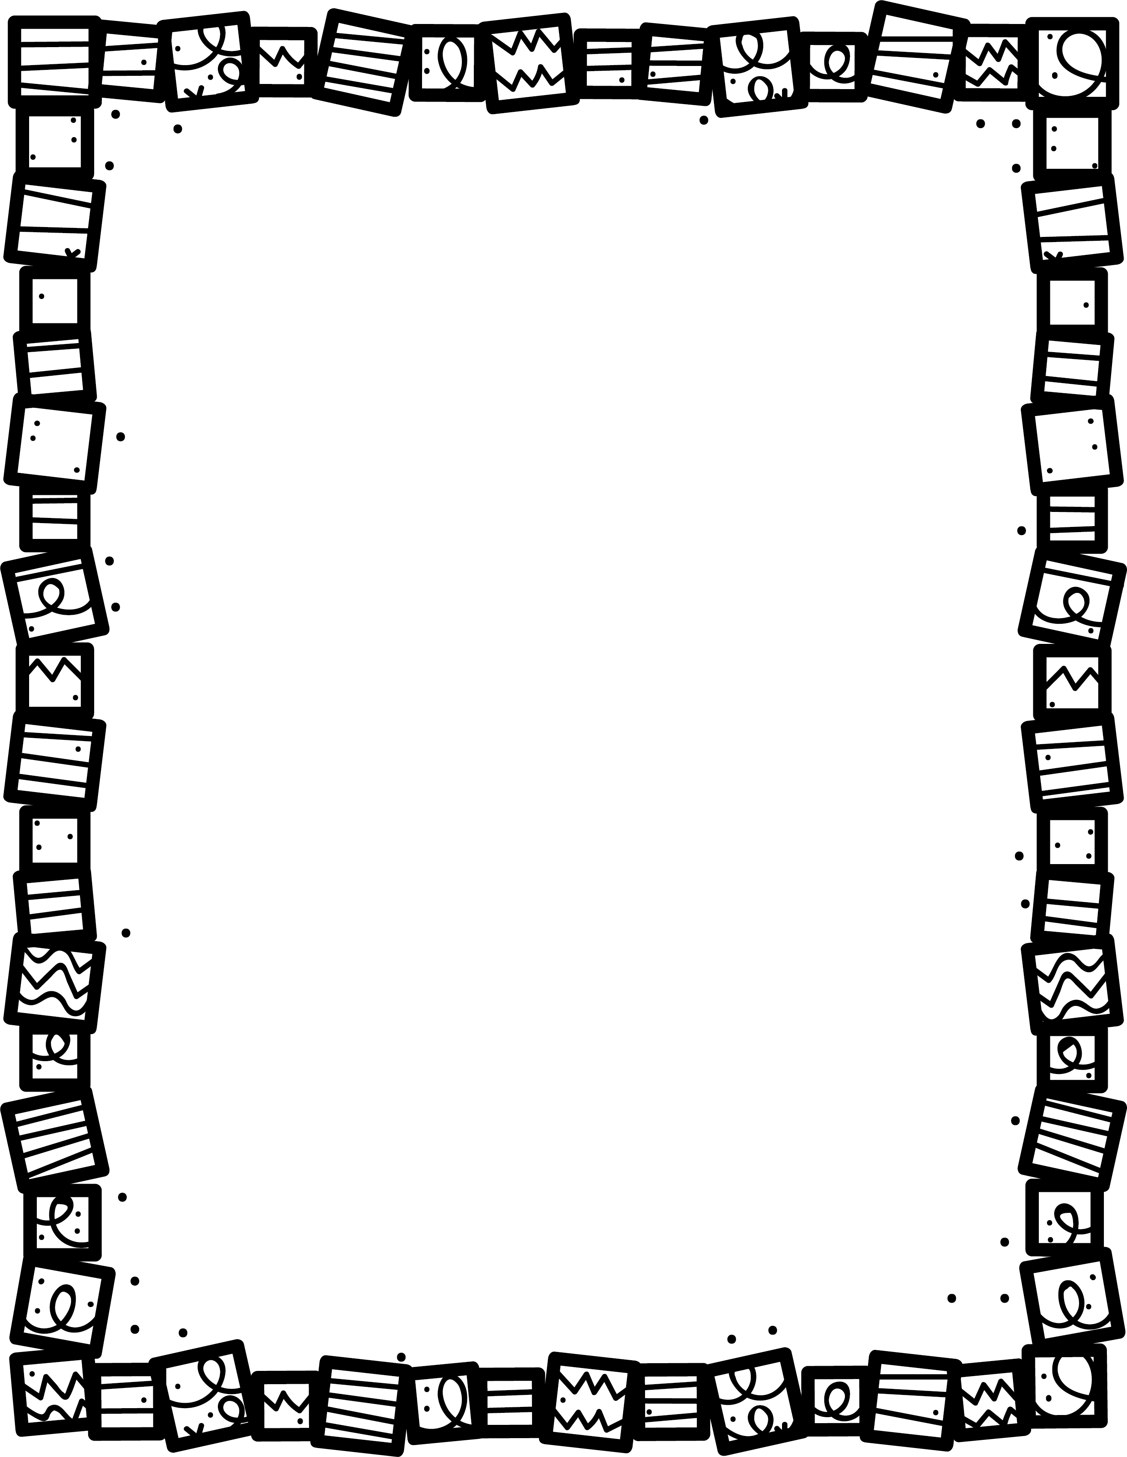

**Describe how the problem in this story is solved. How does it end?**

**What was your favourite part? Why?**

Realistic Fiction

**What makes this book realistic?**

**Describe the plot. What happens in the story?**

**What is the setting?**

**Who are the main characters?**

**Book Title:**

**Name:___________________________**

**My Little Activity Book About**