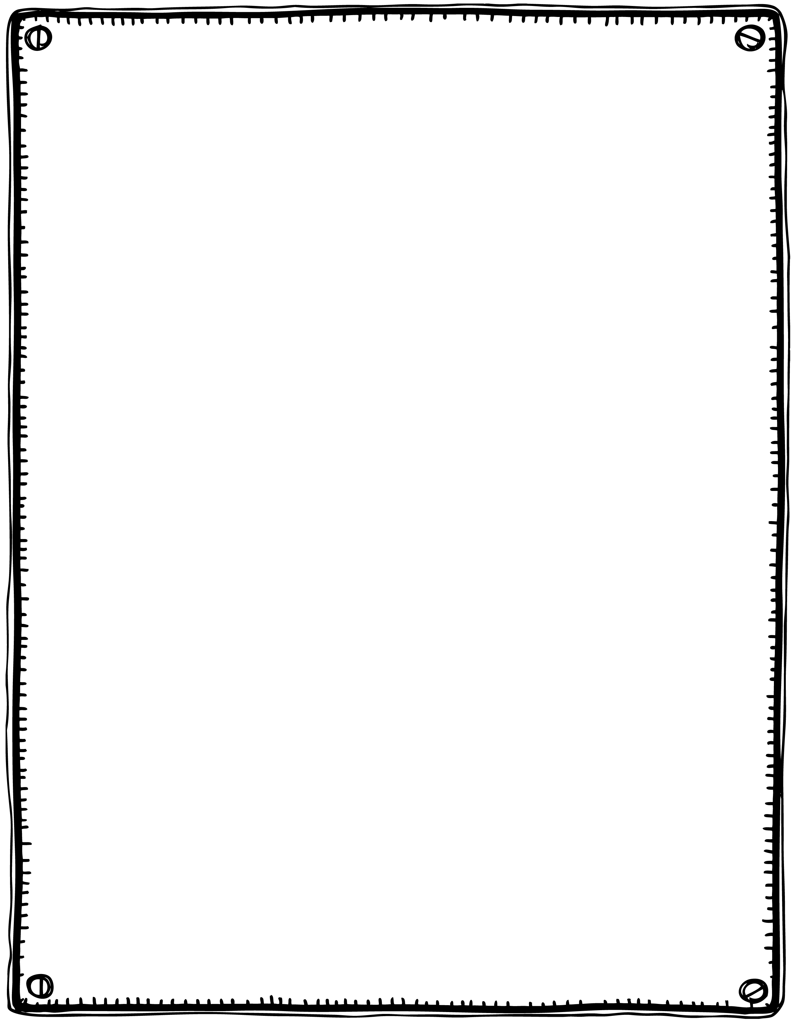

Twinkle, twinkle, little star,

How I wonder what you are.

Up above the world so high.

Like a diamond in the sky.

Twinkle, twinkle, little star,

How I wonder what you are?

**Twinkle, Twinkle**