Name:______________
Class:______________

Communities

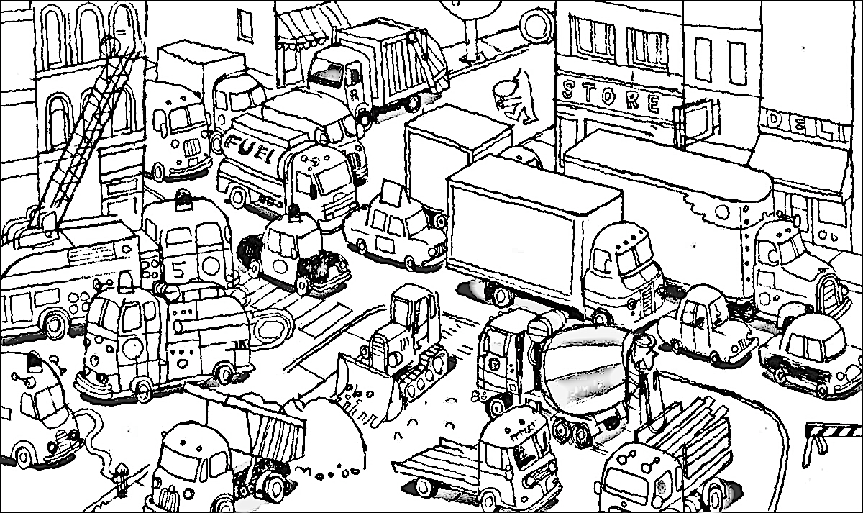

A.
What would you like to do in a city?
____________________________________________________________________________________________________________
Draw a picture
B.
Finish each sentence. Look at the website text for the answers.

1. You can ____________ and ____________ in a city.

2. A city has ________________ for borrowing books.

3. A city has many _____________ where you can eat.
C.
Look at the website text to answer the questions.
1. Where can you go to play outside? ___________________________
2. Who drives a bus? ____________________________
3. Where do you go for dinner? ___________________________
4. Who do you call if there is a fire? ___________________________
5. Where do you buy food? __________________________

D.
Read the website text - ‘How are apartments made?’
Imagine you are building a house or an apartment. Draw a picture of your job.

E.
Match each picture by drawing a line to the correct word.

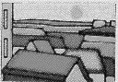 door

wood
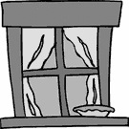 yard
concrete
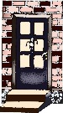 bricks
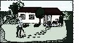 window
roof
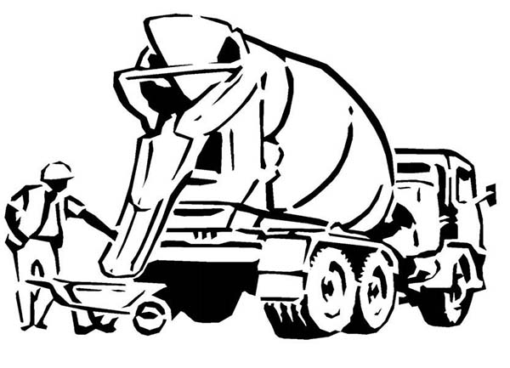 glass

