Name:______________
Class:______________

Communities

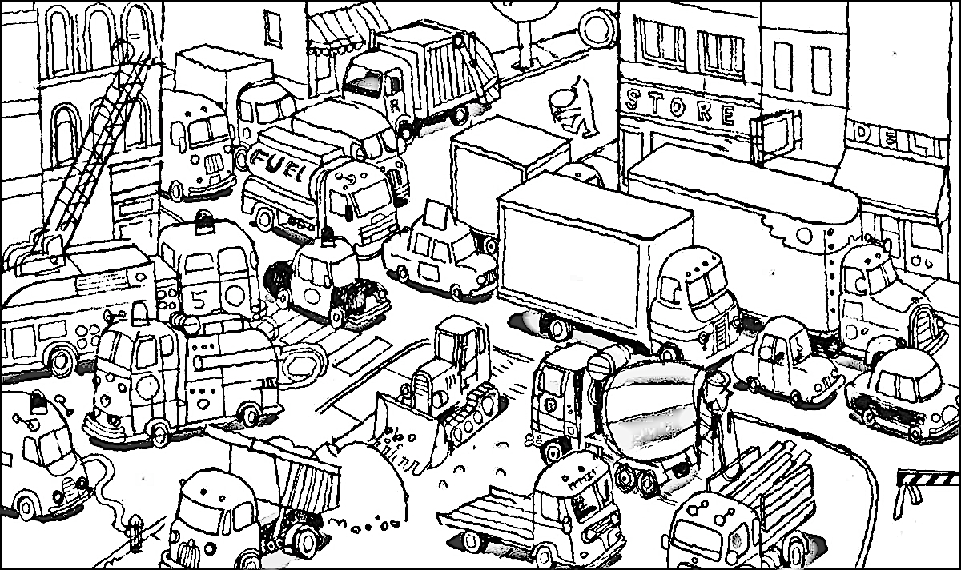
What would you like to do in a city?
____________________________________________________________________________________________________________
Draw a picture of you in the city.
Activity 1 What can you do in a City?
Finish each sentence. Look at the website text for the answers.

1. You can _w_________ and _l__________ in a city.

2. A city has _L____________ for borrowing books.

3. A city has many _r___________ where you can eat.
Activity 2 Who works in a City?
Look at the website text to answer the questions.
1. Who do you call if there is a fire? ___________________________
2. Who works at hospitals? _d___________and__n_________
3. Who drives a bus? ___________________________
4. Who brings your dinner in a restaurant? ___________________________
5. Would you find a bank in the city? __________________________

Activity 3 Living in towns or on a farm
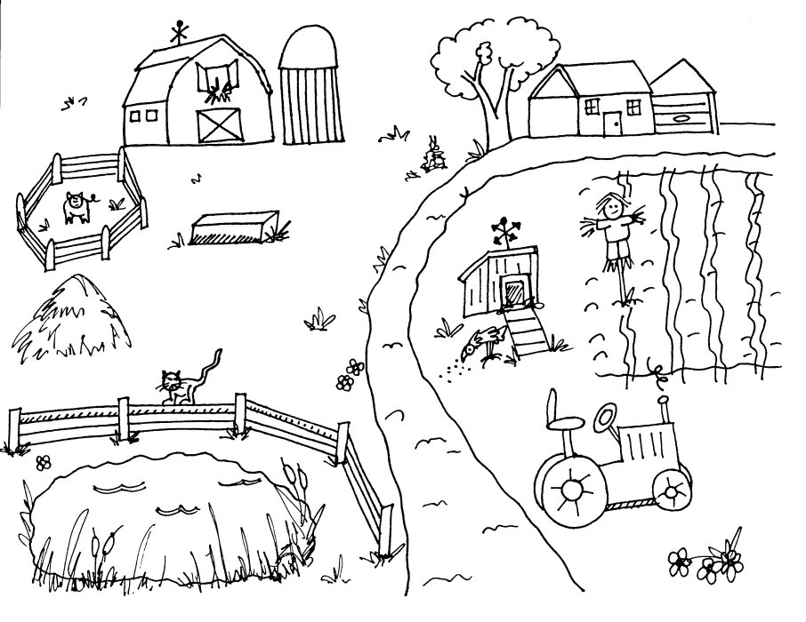
1. A town is a s________ city.

2. A town has sch_______ and h________ and st_____.

3. A town has more space for p_______.

Draw a picture of you working on the farm.

