Map of Moorebank
How to get to _______________________________________________
Directions written by__________________________________________
Directions followed by_________________________________________
Class:_____________________________________________________

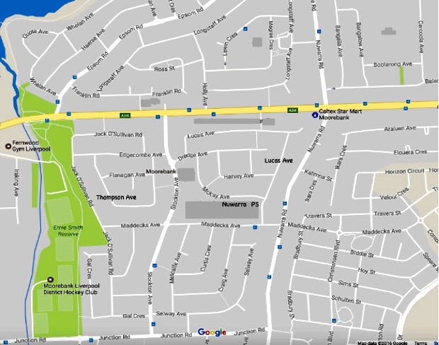
Evaluate the directions by shading one box on each line that best describes your experience.
I found the directions:
Easy to read | Mostly easy to read | Confusing to read | Difficult to read
Left & right always correct | Left & right mostly correct | Left & right often incorrect | I got lost.
The pictures were very helpful. | The pictures were a bit helpful. | I could not find the same places as the pictures. | I wish you had more pictures to help me.

