Dot to Dot in Microsoft Word

Use the Scribble Tool (from the Shapes menu) in Microsoft Word to complete the Dot-To-Dot below.

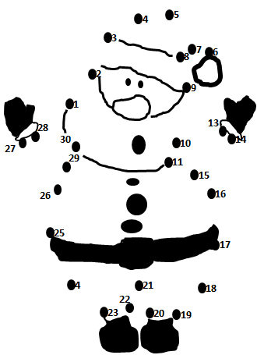

Name:

