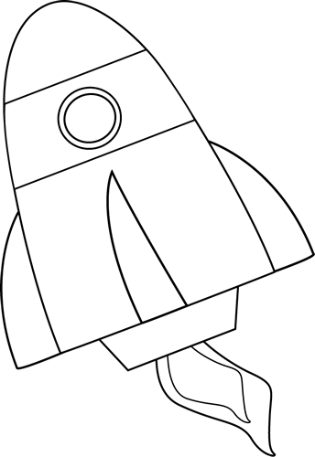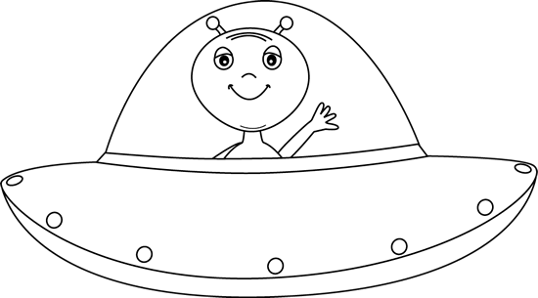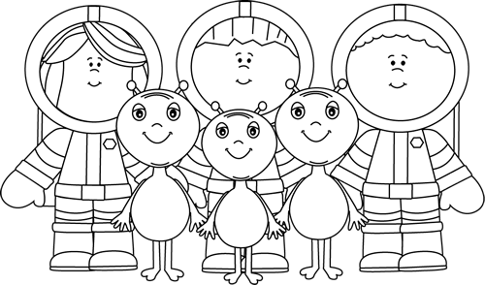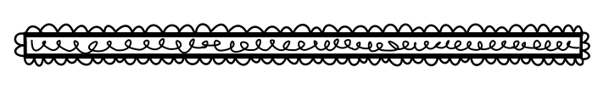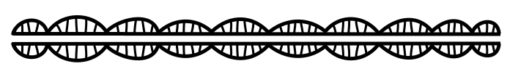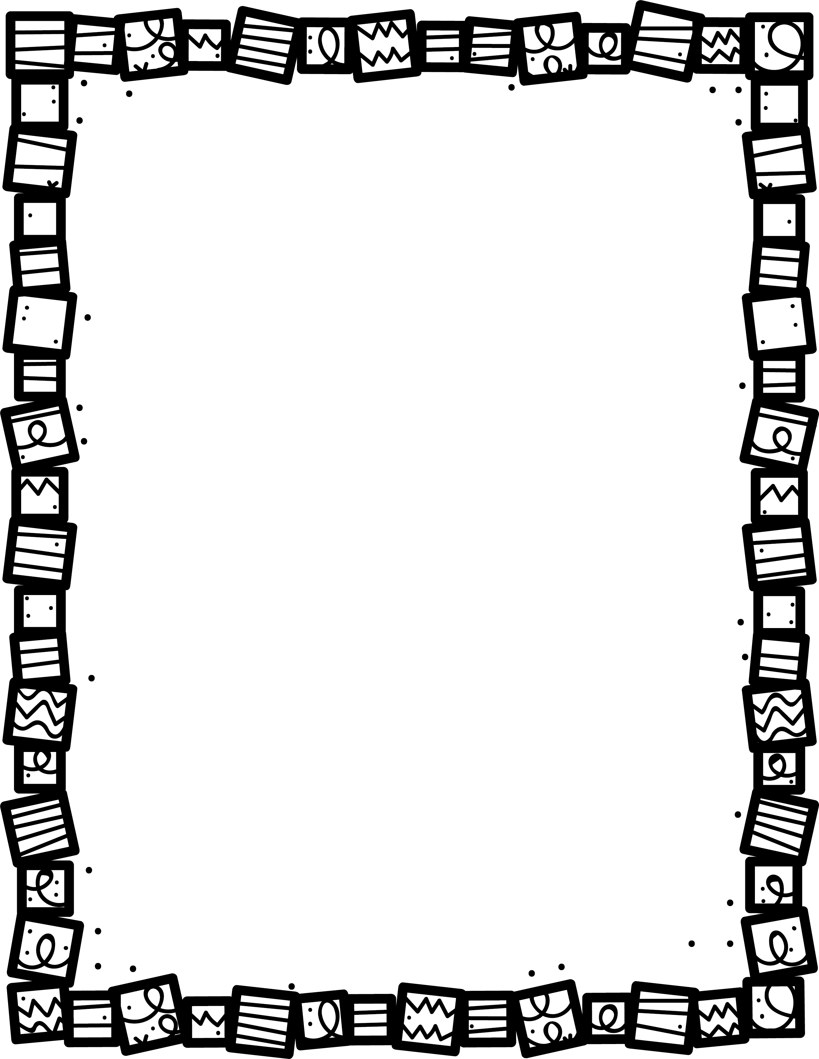

**How do you know this book is Science Fiction?**

**What is the setting?**

Science Fiction

**Describe the plot. What happens in the story?**

**Explain how the story ends.**

**Who are the main characters?**

**What details in the story are real scientific facts?**

**Book Title:**

**Name:___________________________**

**My Little Activity Book About**