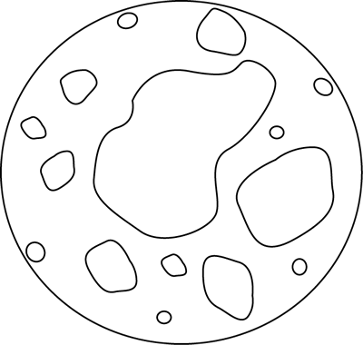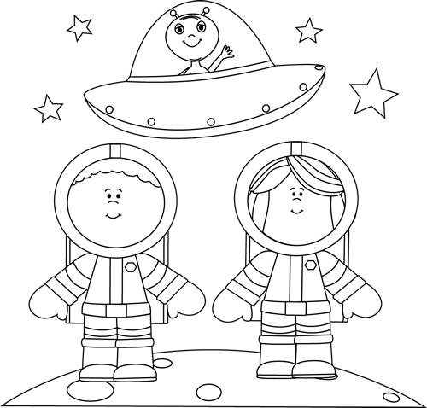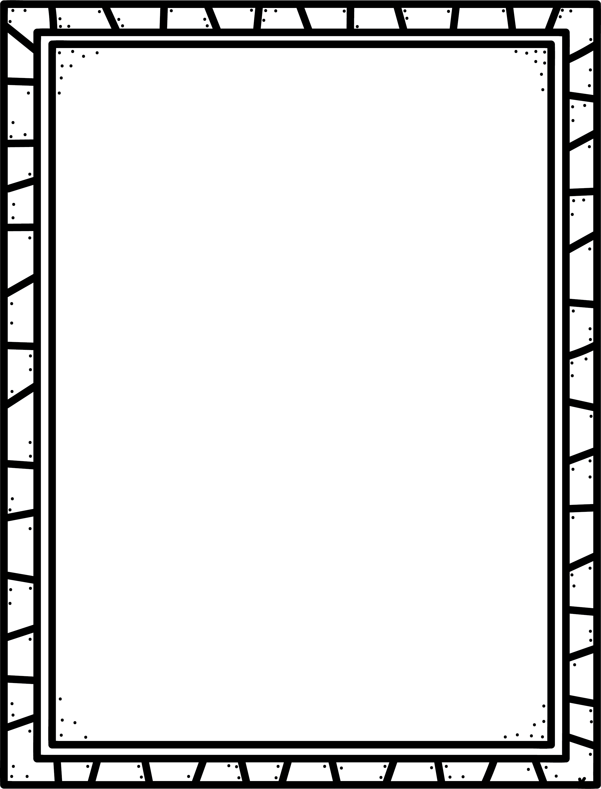

**Characteristics of Science Fiction**

* Usually tells about science and technology, or are about the future
* Some true details are included, like things we know about space.
* Common settings and themes are space, time travel, different worlds and the future.
* Often called sci-fi.

Science Fiction

**Good Readers Know About Genres**

**Some science fiction stories or series I know are:**

**Author’s Purpose:**

**To entertain**

**Keep track of the sci-fi stories you read here!**

**Name:___________________________**