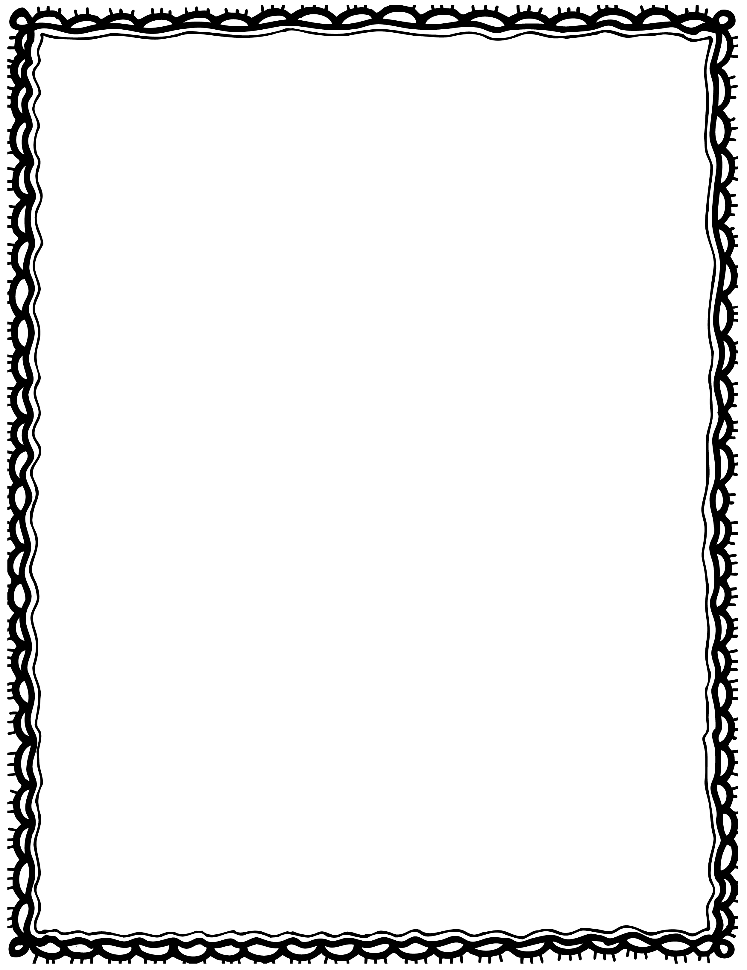

|  |  |
| --- | --- |
| small This cake.is a |  |
| cake. is This a tall |  |
| has a whistle. He birthday |  |
| balloon. has a She |  |
| The confetti. throws boy |  |
| The gift. has a girl |  |

Please Repair the Sentence

Name(s): Class: