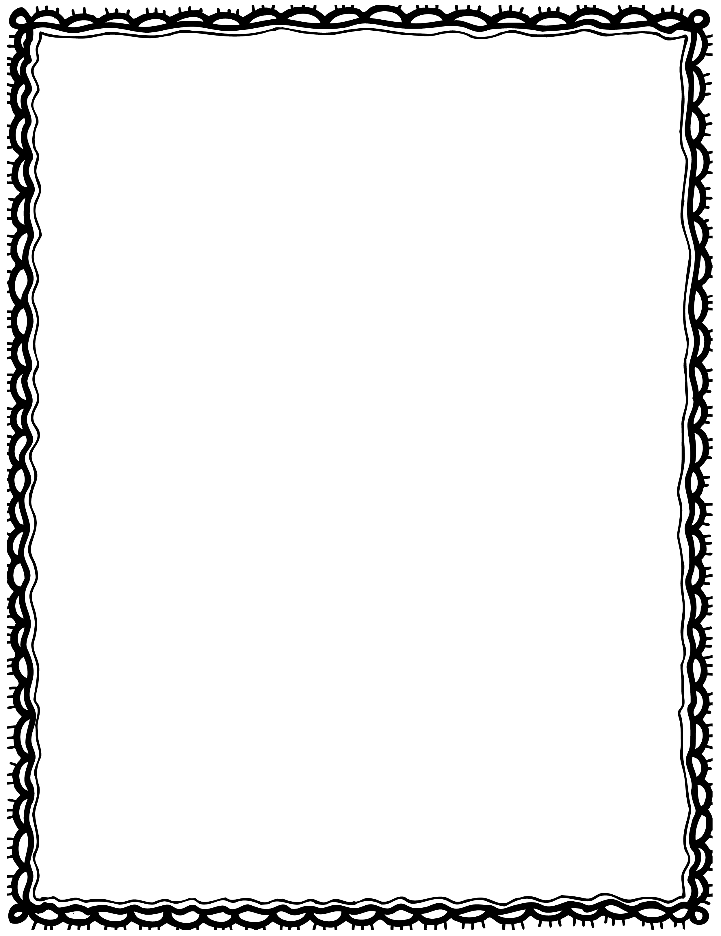

|  |  |
| --- | --- |
| mug. see a blue I |  |
| green see a I lamp. |  |
| clock. I alarm see an |  |
| I mat. a blue see |  |
| see I a on a rack. towel |  |
| cutlery. see a plate and I |  |

Please Repair the Sentence

Name(s): Class: