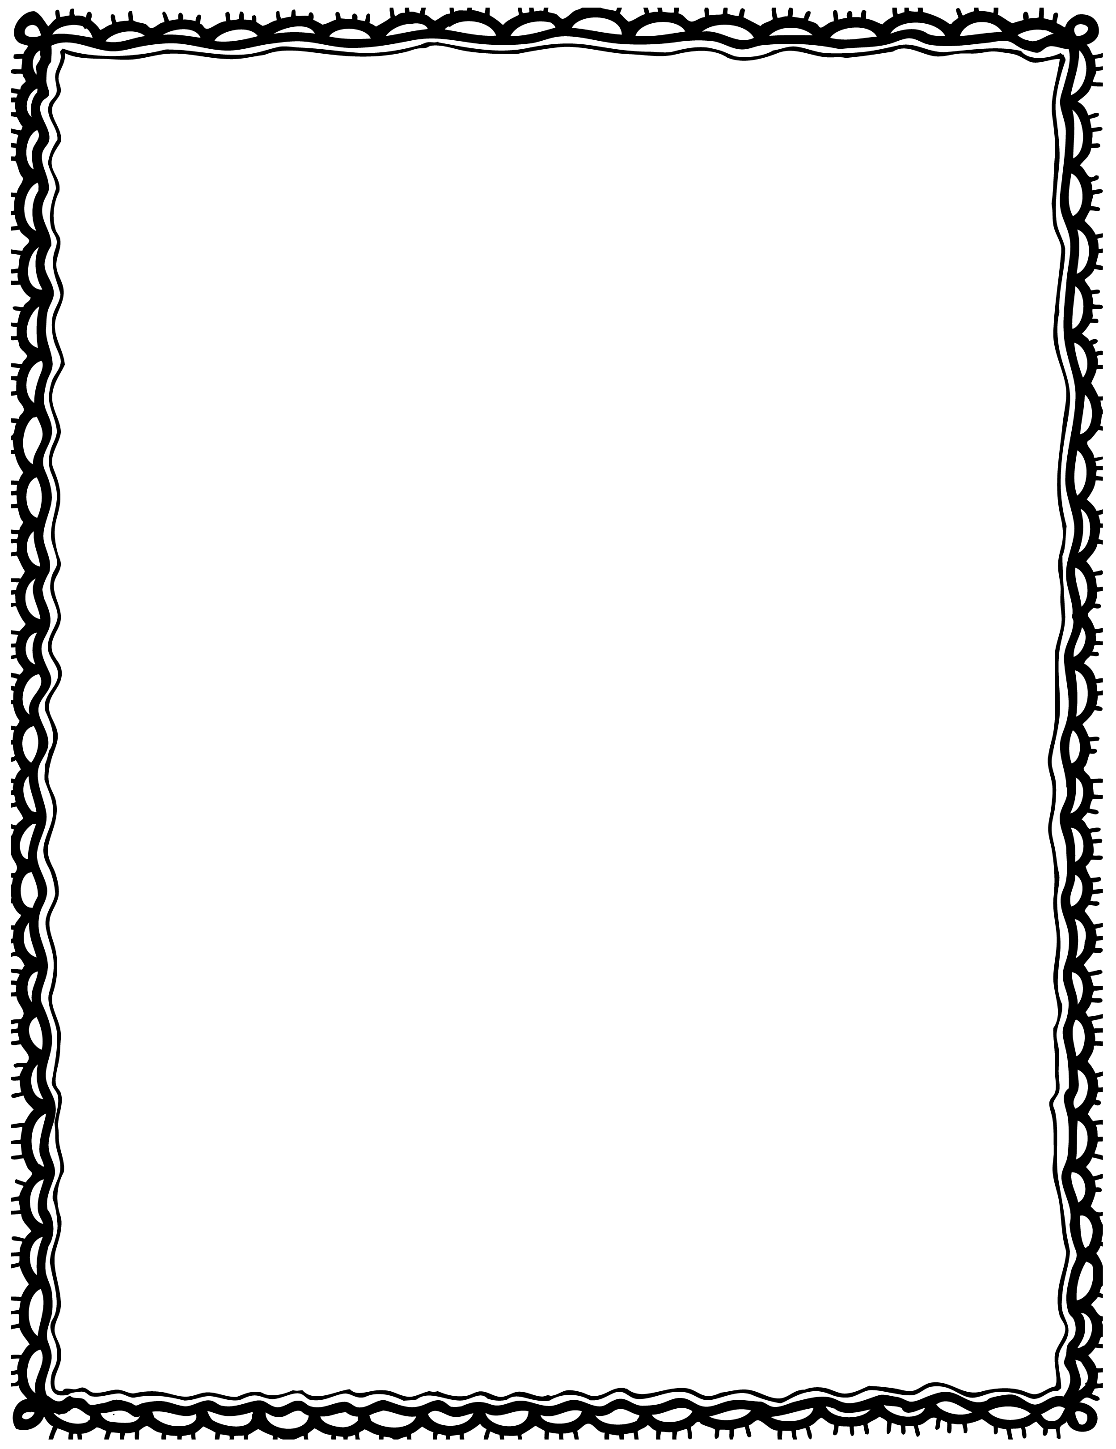

|  |  |
| --- | --- |
| see I a pancakes. stack of |  |
| brown I a egg. see |  |
| chips. see I |  |
| milk. She drinks |  |
| see I a bread. loaf of |  |
| is This butter. peanut |  |

Please Repair the Sentence

Name(s): Class: