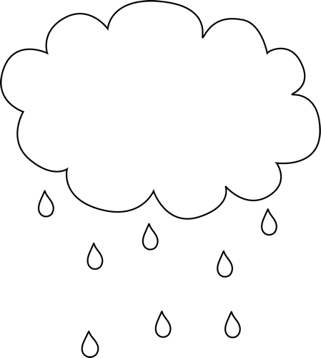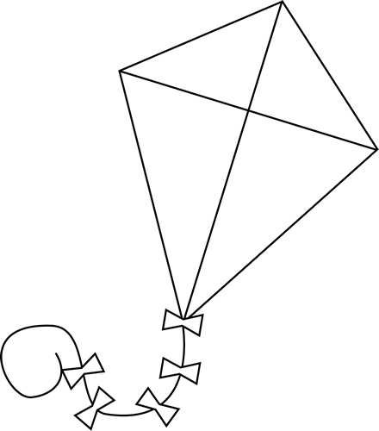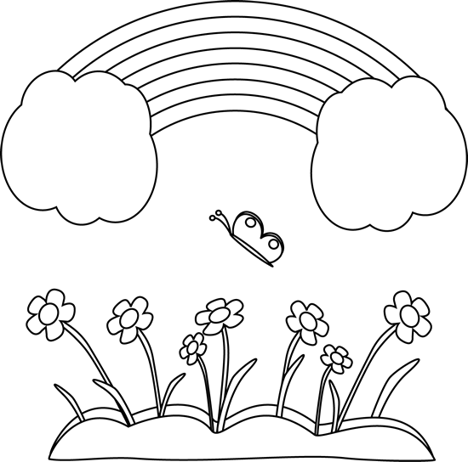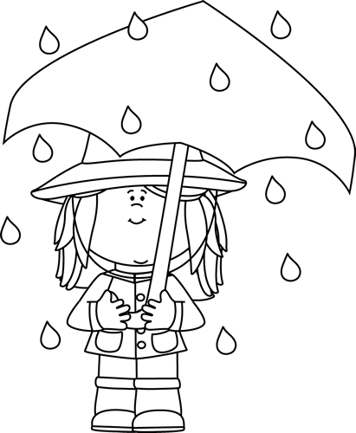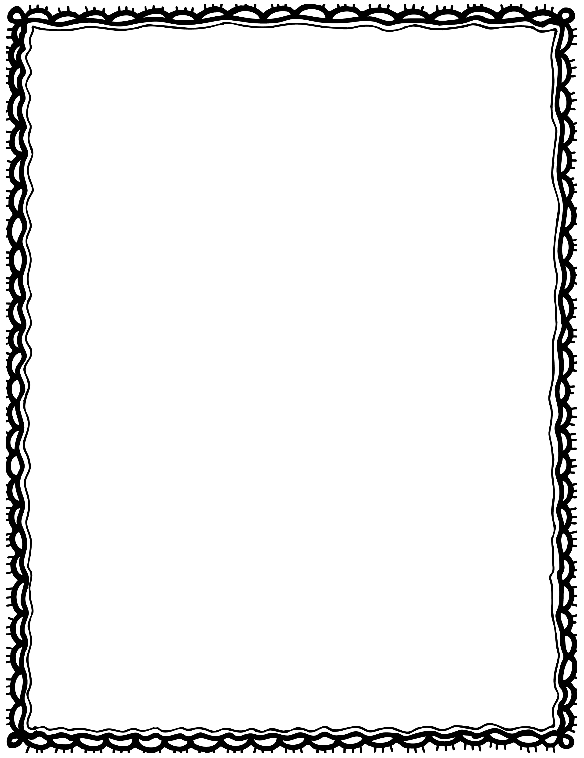

|  |  |
| --- | --- |
| storm. a I see |  |
| umbrella. I see a under duck an |  |
| girl The is standing rain in the. |  |
| colourful Rainbows are. |  |
| need Kites wind. |  |
| raining. This is cloud |  |

Please Repair the Sentence

Name(s): Class: