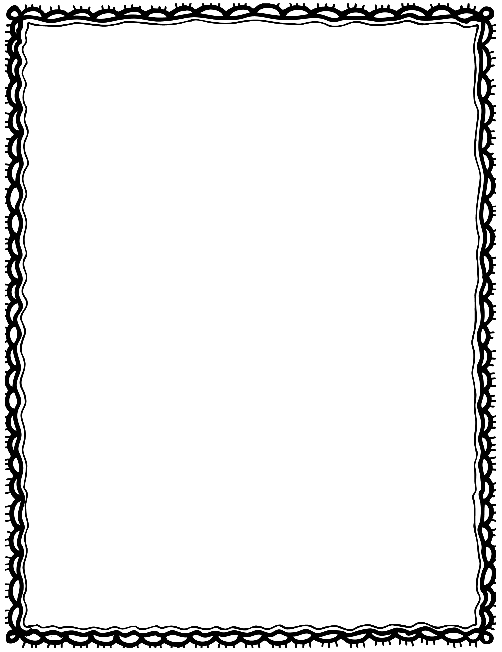

|  |  |
| --- | --- |
| circus is This tent. a |  |
| ate We peanuts. |  |
| lion The stool. sat on a |  |
| A car. drove clown a |  |
| balloons. The four clown had |  |
| wore The stilts. juggler |  |

Please Repair the Sentence

Name(s): Class: