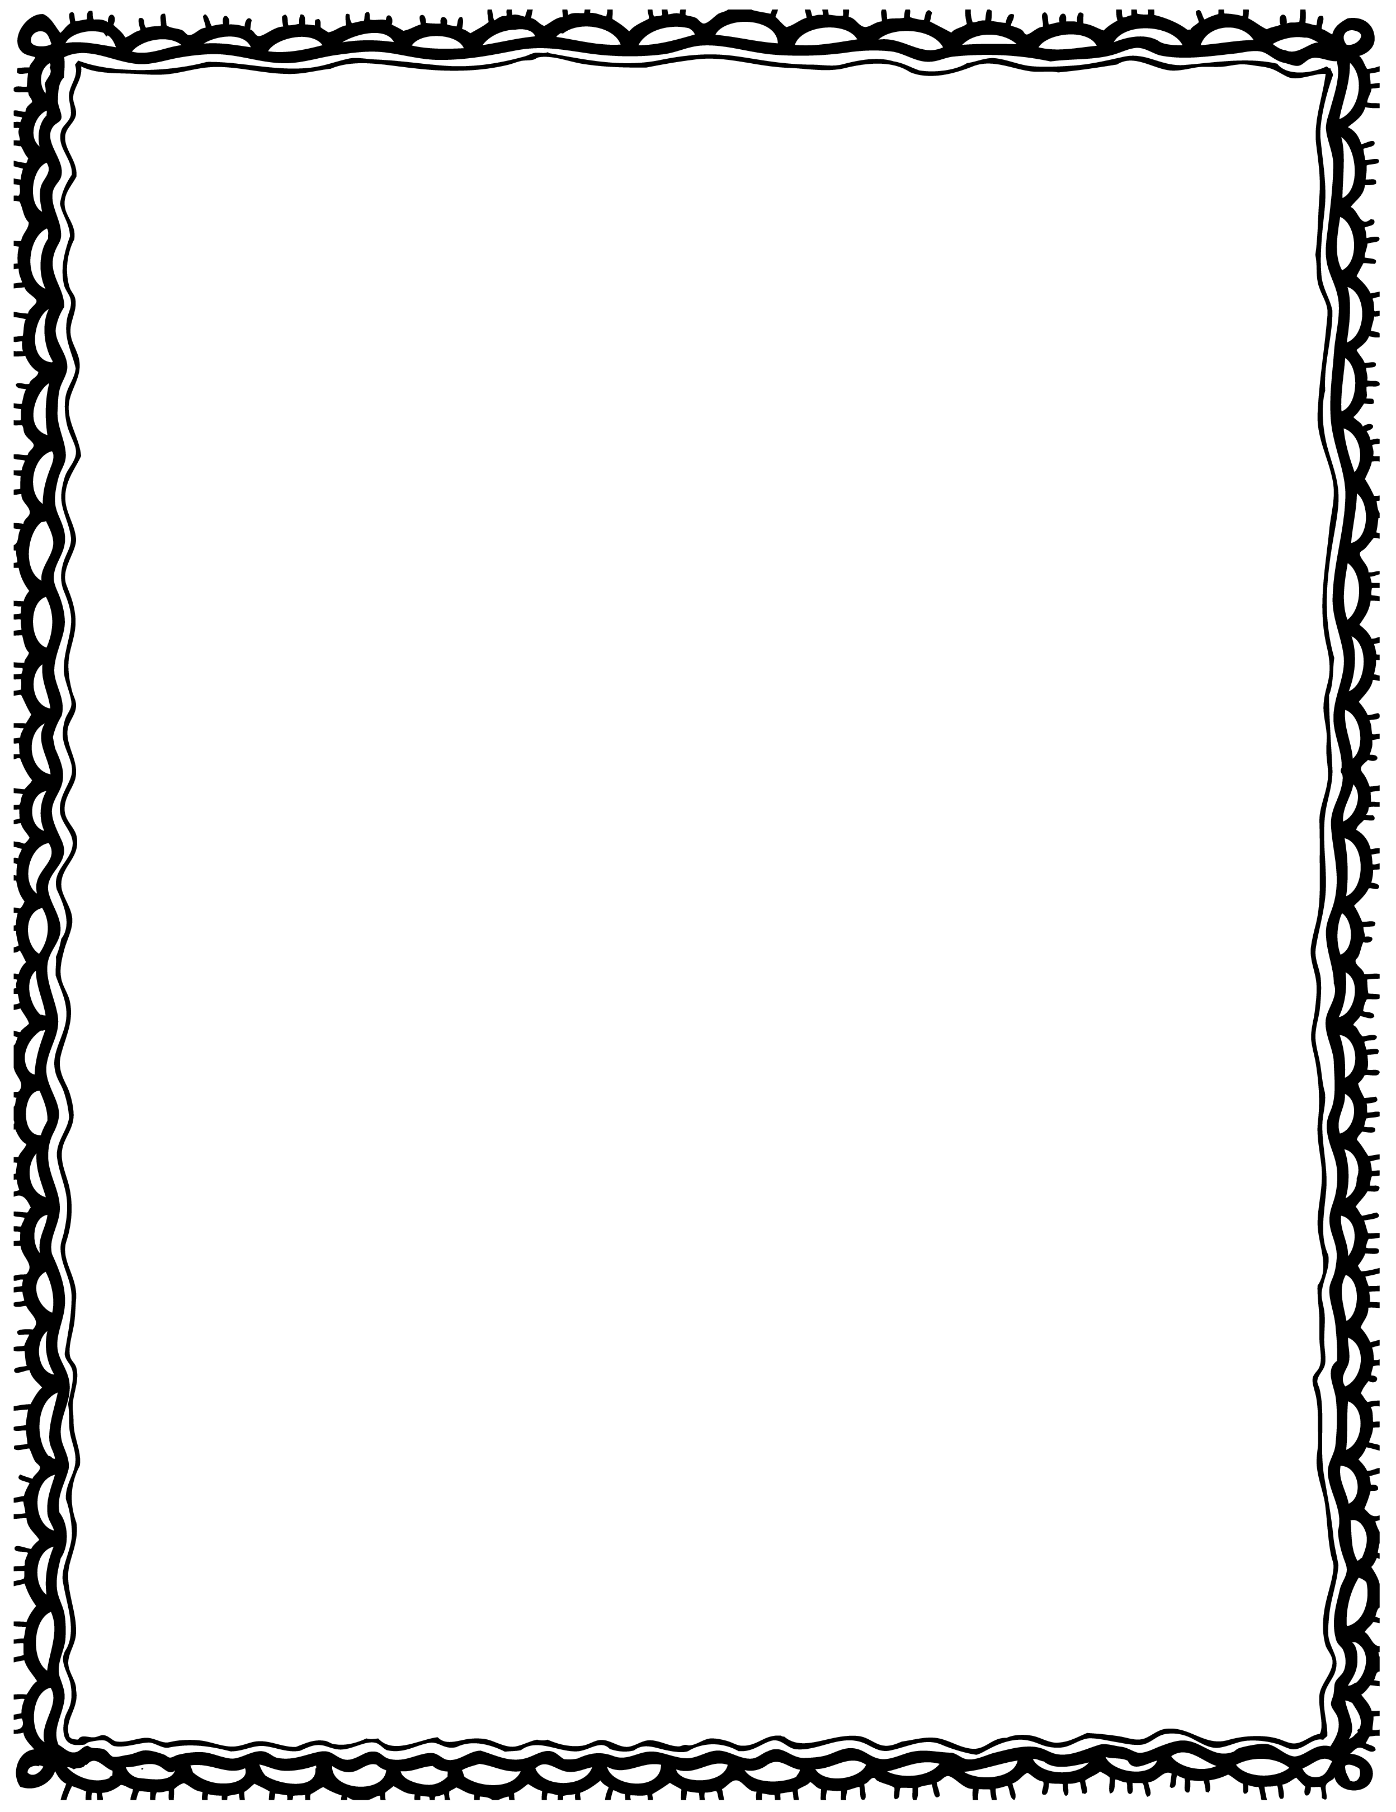

|  |  |
| --- | --- |
| chest. This a is treasure pirate |  |
| pirate The ship four had crew. |  |
| The pirate eye had an patch. captain |  |
| always Pirates treasure maps. have |  |
| looks A parrot the treasure. after |  |
| too! pirates are Girls |  |

Please Repair the Sentence

Name(s): Class: