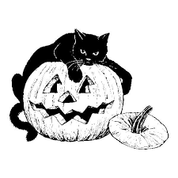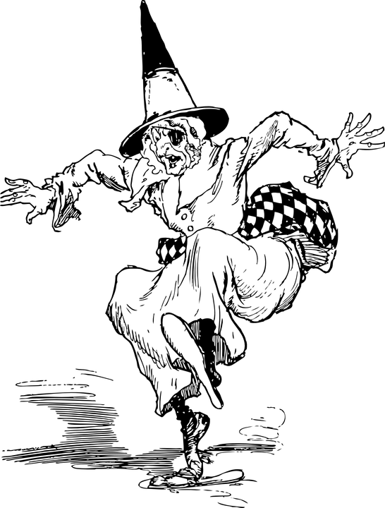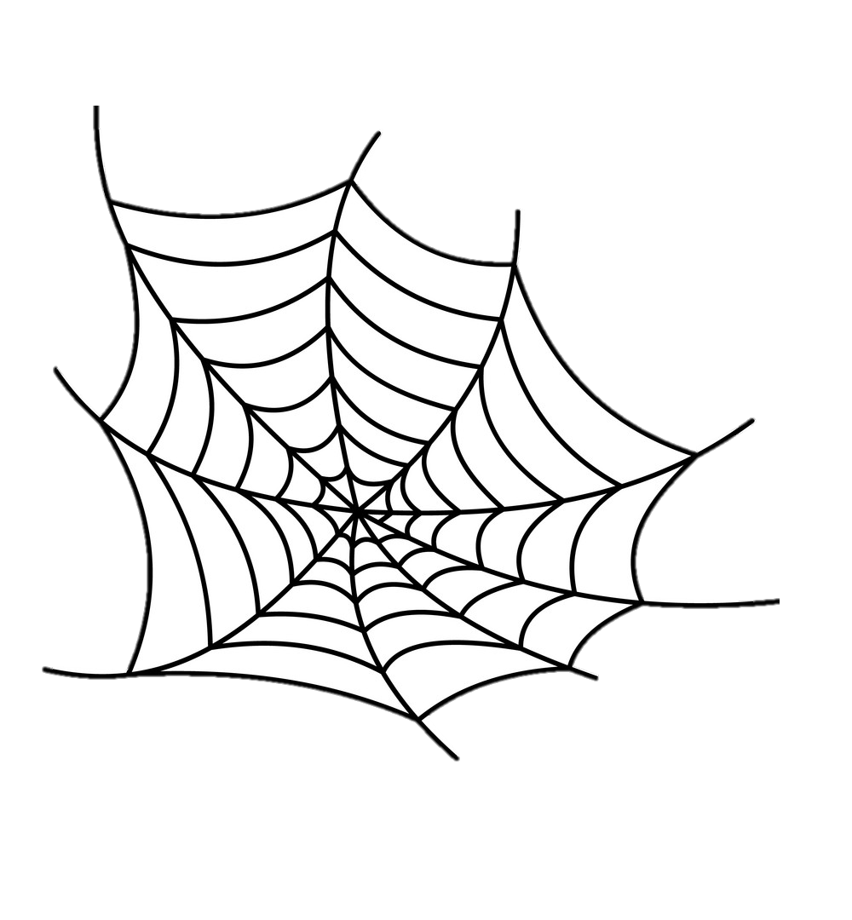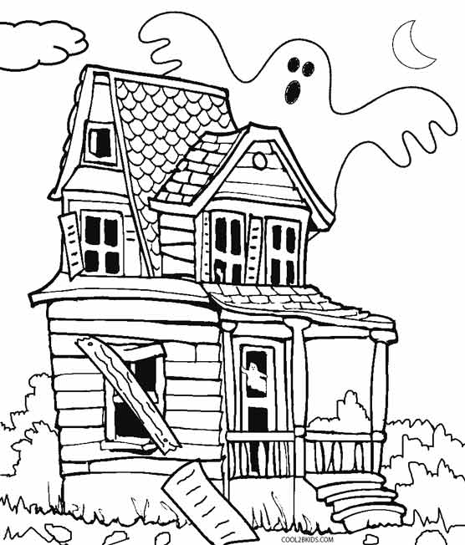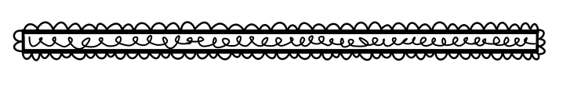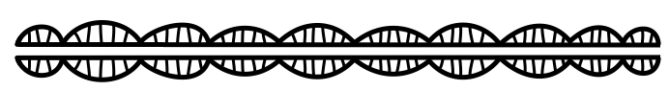

Spooky

Stories

**What are some of the spooky events?**

**What is the spookiest part? Explain.**

**What was your favourite part? Why?**

**Describe the setting. What makes it spooky?**

**Is there a twist in the story? Explain.**

**What is strange about the characters?**

**Book Title:**

**Name:___________________________**

**My Little Activity Book About**